OMNI T3D Engine

Programmers Manual

Winterleaf Entertainment L.L.C.

# Foreword

I set out over five years ago to build a game with a couple of friends. We had no idea how difficult the endeavor would be and had I known then what I know today, I might not have taken on the challenge. It seems that no matter what engine you use, you always find a short-coming in it. Some are more expensive than others, some are more refined than others, and it always seems the more refined the engine the less access to source code you have.

Our first attempts at building our game focused mainly on C++ programming. We quickly found out that you should not be doing game logic in C++. It lacks the necessary flexibility to prototype quickly. We also discovered during this process that each engine had a custom language. Some custom languages were better than others, but overall, they required learning a language that was unique to the engine and would not translate easily if you wished to change engine technology mid development.

After the development of our game flopped, we sat back and re-evaluated where we had made wrong turns and bad decisions. As a programmer I was focused on the language and structure, whereas our artists were focused on eye candy and pipe-lines. After doing some serious soul searching, and many hours talking to the other team members we decided to take on a challenge so big it seemed impossible.

I made a promise back then to my team members. The promise was simple, “I would not quit until everyone else did.” The funny thing is that the other team members made the same promise. So now we had this team that was committed to solving the problems and no one wanted to be the person to go back on their word. It became an all or nothing situation.

After many prototypes and attempts at building a better engine Winterleaf Entertainment L.L.C. released the first version of an attempt to build a better engine. It was more of a bolt on to an existing engine than its own engine. The bolt on (DotNetTorque) improved performance of the T3D engine by an easily 20-25 percent and allowed developers to start writing the scripts which ran their games in C# versus the stock proprietary language for the engine called TorqueScript. Currently there are over 20 games being developed currently using this modification for T3D.

After taking a couple months off, (Actually I wrote a product called OneWorld, but that’s a different story) I came back to the engine and took a fresh look at what I was trying to accomplish. I used every static code analyzer and performance monitor known to man to benchmark the source code. After a couple weeks of research I realized that not only that I could do a better job, but the changes I was proposing would simplify the programming pipeline.

To prevent any sins from DotNetTorque carrying over to the new product I started from scratch and OMNI was born.

After demonstrating the power of Omni to other engine programmers we realized that the new short coming in the engine wasn’t the C# framework but the old open source engine we were was using. Several very talented engine programmers decided to join my effort by re-writing many parts of the original C++ engine code.

They started by tackling the obvious things like native 64 bit support, OpenGL, shader systems and the like. Unlike other efforts like ours, we started with a Road Map which documented where we wanted the engine to go. So even though our developers tended to work on things they liked, they were restricted to only items on the Road Map. This prevented massive scope creep by keeping all of us corralled.

The development of the engine slowly became a show-off competition where each of us would like to rub in each other’s noses what we had pulled off. The competition has grown quite fierce and today it continues to grow.

Finally, the fruit of our labor paid off when we hit the last milestone in our development Road Map and Omni was born. Omni is a 3D engine design for all types of games and simulations. The core of the engine is written in C++ and all scripting is performed via C#. Omni represents the collaborative efforts of many programmers focusing on common goal of building an engine that is friendly to developers and artist alike without sacrificing performance.

Table of Contents

Foreword 2

Frequently Asked Questions 8

What is the Omni T3D Engine? 8

Why should I use your engine when I can get T3D free? 8

How different is Omni from T3D? 8

Can I build a MMO/MMOFPS/MMORTS/MMOOMG with Omni? 8

Requirements 10

Chapter 1 Internal workings. 11

Introduction 11

Basics 11

Model–view–controller (MVC) 11

Object Creation 13

Object Destruction 14

Callbacks to Proxy Objects 15

Low Level MIT T3D Engine Function Calls 15

Chapter 2 Installation 16

Omni Engine 16

Omni Engine Tools 16

Chapter 3 Creating your first Game. 20

Project Manager 20

Generated Solution Files 27

Omni Framework Solution 27

<Project Name>.sln Solution 34

Omni Live Scripts Solution 37

Static Code Generator - Update the Omni Framework Code 38

Static Code Generator (Visual Studio Extension) 39

Step 1, Check out the source code (if applicable) 39

Step 2, Open the “Omni Framework Solution” 39

Step 3, Open the Static Code Generator Extension 39

Step 4, Select the Omni C++ DLL project 40

Step 5, Select the C++ DLL Project 41

Step 6, Select the Winterleaf.Engine project. 41

Step 7, Select the C# Game Logic Project 41

Step 8, Review the configuration 42

Step 9, Click “Generate” 43

Step 10, Recompile 44

Static Code Generator (Stand-Alone) 45

Step 1, Check out the source code (if applicable) 45

Step 2, Start the Static Code Generator (Stand-Alone) 45

Step 3, Click “Select Omni T3D Solution File” 46

Step 4, Select the “<Project Name>.sln” file. 47

Step 5, Click “Select Omni Framework Solution” 48

Step 6, Select the C++ DLL Project 48

Step 7, Select the Winterleaf.Engine project. 48

Step 8, Select the C# Game Logic Project 48

Step 9, Click “Execute” 49

Step 10, Wait for the Static Code Generator to finish. 50

Step 11, Add new files to the “C# Game Logic Project” 50

Step 12, Recompile 52

Running the Game 54

Chapter 4 Customizing Winterleaf.Game Executable Name 55

Chapter 5 Customizing Winterleaf.Demo.Full 61

Chapter 5 Object Models Overview 68

Introduction 68

Reasoning 69

Chapter 6 Creating Views (Omni T3D Objects) 70

Introduction 70

There are three rules that apply to all Creator Types: 70

Rule 1: You cannot assign properties after you call the “Create()” function. 70

Rule 2: Any Creator based object being assigned as a property, the property must be prefixed with a “#”. 71

Rule 3: All Creator based objects assigned as properties must be the last properties assigned. 71

ObjectCreator Class: Create Instanced based Views 71

DatablockCreator Class: Create Datablock based Views 72

SingletonCreator Class: Create Singleton based Views 73

Creating Objects in TorqueScript 74

Chapter 7 Extending the User.Models.Extendable 75

Member Functions (Overriding T3D engine Callbacks) 75

“ConsoleInteraction” Decoration 76

Member Variables 77

Traditional Member Variable 77

C# Member Variable 78

Hybrid Member Variable 78

Static Member Functions (Global functions) 78

Function: OnFunctionNotFoundCallTorqueScript 79

Chapter 8 Custom Models 81

Chapter 9 Building Gui’s and converting them to C# 84

Using the GuiParser 84

Advanced Gui Creation 87

Old Style 87

New Style 87

Chapter 10 Global Functions 90

Chapter 11 Run-Time C# Programming (LiveScripts!) 91

Chapter 12 File Dialogs 96

Chapter 13 Threading with the Omni Framework 98

Chapter 14 Debugging C# and C++ 102

Appendix 112

Appendix 1 - Static Code Generator Configuration Options 112

Configuring C++ Class pInvoke Serializations 112

Configuring C++ Class/Enum Map to C# Class/Enum 112

Configuring C++ Class/Function Ignores 113

Configuring C++ Constants 113

Configuring C++ Return Type Casting Overrides 113

Configuring C++ SimObject Based Classes 114

Configuring C++ Source Files To Ignore For Enumeration Parsing 115

Configuring C++ Source Files To Ignore On Interrogation 116

Appendix 2 - Special Omni C# Syntax 117

Appendix 3 - Built in conversion functions for Casting. 119

Appendix 4 - Casting Game Objects 120

Appendix 5 - Overriding functions and such 122

Appendix 6 - Creating Objects (ObjectCreator/SingletonCreator/DatablockCreator) 123

Gui’s and nested Objects 124

Appendix 7 - uGlobal, sGlobal, iGlobal, bGlobal, fGlobal, dGlobal, fGlobal 125

Appendix 8 – OMG I have a ton of “WARNING:: COULD NOT RESOLVE… in my console” 126

Appendix 9 - Where did “ClassNameSpace” and “superclass” go? 127

# Frequently Asked Questions

## What is the Omni T3D Engine?

The Omni T3D Engine is a derived engine based off of the MIT Open source T3D project from Garagegames.com.

## Why should I use your engine when I can get T3D free?

This is true, you can download the T3D engine for free from Github and build your game. But there are many differences between Omni and stock T3D.

* C# integration
* Improved Mathematics
* Optimized engine code
* Add more here.

Most importantly you get support from people who work with the engine daily and are constantly pushing the boundaries of the engine’s capabilities.

## How different is Omni from T3D?

Omni is a branch version of T3D. Just like RedHat and Ubuntu are branches of Linux, Omni is a branch of T3D. Omni can run a TorqueScript game, and run it quite fine but of course it’s designed to run optimally in C#.

A knowledge of the MIT T3D project won’t hurt you when it comes to Omni. Mechanics are mechanics and for the most part they are the same. The biggest difference is in the syntax and object oriented design of the script code structure.

There are some differences in the way you do things between Omni and MIT T3D, some of the more noted ones include threading, file dialog boxes, and just in time script compilation. Another big difference between Omni and MIT T3D is in inheritance. MIT T3D’s scripting interface only allows a very limited form of inheritance of objects. Omni on the other hand allows programmers to inherit to any depth and create rich object oriented design using C# inheritance.

## Can I build a MMO/MMOFPS/MMORTS/MMOOMG with Omni?

Can you? Yes you can. One of the biggest problems with the MIT T3D code base is that simple things like database interaction has to be added to the engine per build. Want to add “Some Library for communication”, you need to find the C++ code base and shoehorn it into the T3D C++ engine.

With Omni, adding database support is as simple as including a reference to the C# project. If you can find a Microsoft.Net DLL to do what you want you can roll it into Omni with ease. You can extend Omni to do things that would just take months in MIT T3D.

Imagine building a simulator that shows the layout of your house, and if you click a door you want to unlock the door remotely. Doing this in MIT T3D would be painful at best, but with Omni, you just include the Microsoft.Net DLL and go on your merry way.

Omni enables the MIT T3D SDK to leverage Microsoft.Net to simplify programming and prototyping.

# Requirements

1. Visual Studio 2010 or 2013
   1. The Professional version is preferred. Visual Studio 2013 can be purchased without the MSDN support for about $300 dollars here. (<http://www.microsoftstore.com/store/msusa/en_US/list/ThemeID.33363200/categoryID.62687600?WT.mc_id=vssitebuy_2013>)
   2. If $300 dollars is out of your price range, visit <http://www.microsoft.com/bizspark/> , signing up only takes a few minutes and you gain access to all of Microsoft’s tools free. You do need to renew it each year by clicking a button on their website.
2. Microsoft Dot Net version 4.0 or greater
3. I recommend a decent video card and computer, or the builds will take forever. I currently use an old Intel Core 2 Quad with 8 Gigs of ram to build the engine and it seems adequate.

# Chapter 1 Internal workings.

## Introduction

Most approaches done by various engines are similar, they use a series of Platform Invocation Services (P/Invoke) defined in the C++ and C# to facilitate communication between the languages. Omni is no different in that regard it uses an extensive list of P/Invokes between the C++ and C#. The feature that sets Omni above the rest is the Framework which rests on top of the P/Invoke foundation.

## Basics

The Omni T3D engine is comprised of 4 major components. Each component serves a distinct purpose in separating the tasks that need to be done for the game to operate correctly. These four layers are the C# Game Harness, Omni Framework, Omni Branch of MIT T3D, and the C# Game Logic. This was done for many reasons but one of the more major reasons was to achieve a Model-View-Controller software design. The below diagram displays the container order of the four major parts.



Model–view–controller (MVC)is a software architectural pattern for implementing user interfaces. It divides a given software application into three interconnected parts, so as to separate internal representations of information from the ways that information is presented to or accepted from the user. The central component, the model, consists of application data, business rules, logic and functions. A view can be any output representation of information, such as a chart or a diagram. Multiple views of the same information are possible, such as a bar chart for management and a tabular view for accountants. The third part, the controller, accepts input and converts it to commands for the model or view. –[en.wikipedia.org](http://en.wikipedia.org/wiki/Model%E2%80%93view%E2%80%93controller)

According to this concept a typical design model follows the following schematic.



Applying this concept to the Omni T3D Engine we end up with:



### Object Creation

Omni uses a concept of creating Model objects for every object inside the C++ engine. These Model objects are state-full and can be passed around in the C# like any other type of C# object. They are created automatically when the C++ engine creates a new object and they are cleaned up and destroyed when the C++ engine destroys them.

In the diagram to the right you can see the process that happens inside the engine when you create a new Simulation Object in the C++.

When the C++ gets a request to create a new simulation object, the engine will make a callback to the C# Omni Framework informing it to create a new Model for it.

### Object Destruction

Object destruction works in a similar fashion to creation. The difference being that the C++ Simulation engine will inform the OMNI Framework to destroy the Model object attached to the Simulation object. After the proxy object is destroyed, the C++ Simulation engine will dispose of the object.

### Callbacks to Proxy Objects

Every simulation object in the game has events. These events can be simple events like “OnAdd” to more complex events related to collisions. When a Simulation Object event occurs, the Model object is looked up in the C# and the member function which matches the event name is called. This is also true if a TorqueScript running inside the engine makes a function call. All function calls are first passed to the C#, if no function exists in the C# and the proxy object is not configured to block TorqueScript, it will then look up the function in any TorqueScripts that might exist and execute it.

### Low Level MIT T3D Engine Function Calls

Unfortunately, sometimes you will still need to call or execute some code which the Omni Framework doesn’t handle or expose. These situations are quite rare, but they do happen. It is because of this several low level functions have been added to the framework. These functions let you evaluate TorqueScript via C# without having to save them to a TorqueScript file. These fringe cases will be discussed later in the document.

# Chapter 2 Installation

## Omni Engine

Run the Omni Engine Install, this program will install the source code for the Engine plus dependencies needed to compile.

**Add screen shots and process.**

## Omni Engine Tools

To build the Omni Framework you will need to run a program called the Omni Static Code Generator as either a plug in to Visual Studio (2010/2012/2013 Standard edition+) or as a standalone program. This program is included in the installation file.

To install the tools run the “Omni Engine Tools Setup.exe"

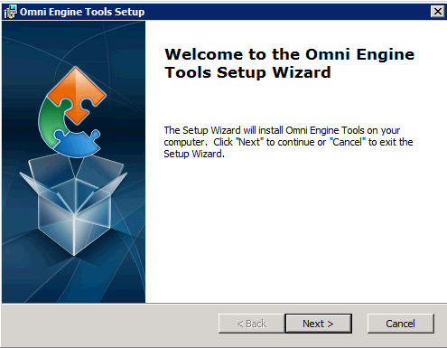

Click “Next”.

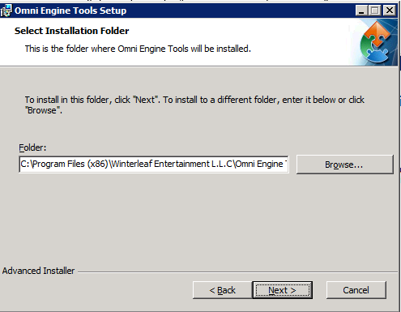

Change the default Location if you want to install it somewhere else.

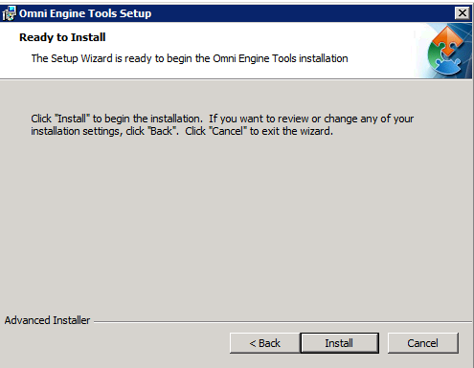

Click “Install”.

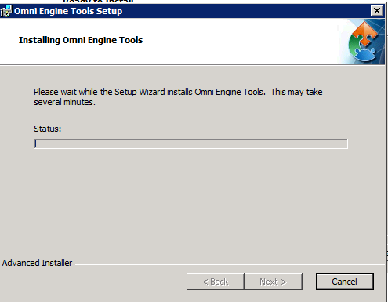

After the install finishes, the Visual Studio Extension installer will run. If you have a compatible version of Visual studio it will show a screen like.

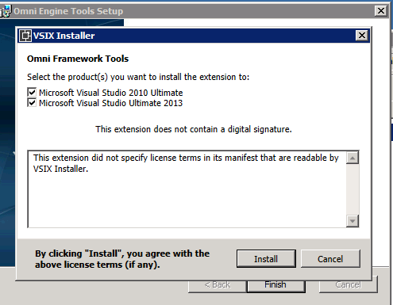

Click “Install” to install the Visual Studio Extension.

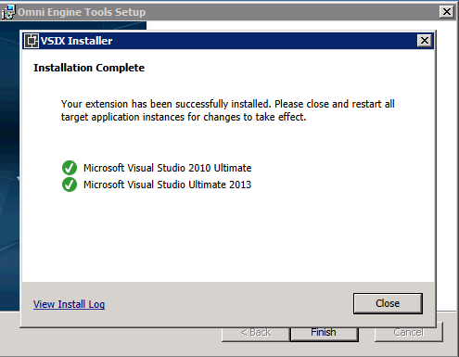

Click “Close” to finish the install.

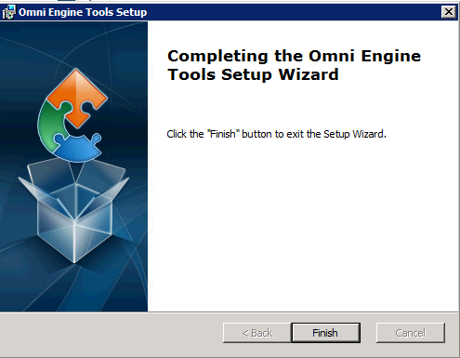

Click “Finish”

# Chapter 3 Creating your first Game.

After installing the software and SDK, the first process is to make your first game.

In the Omni SDK folder you will see a program called “Project Manager.exe”. This program is a toolbox that lets you create new games using the Omni Engine.

## Project Manager

Double click “Project Manager.exe”

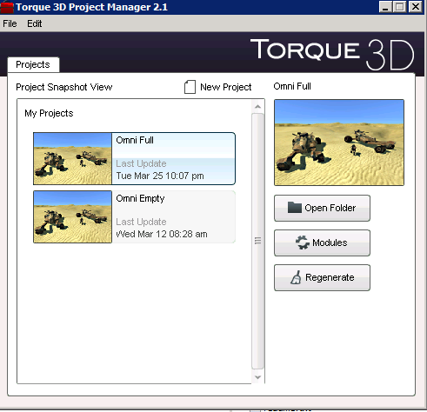

In the “My Projects” scrollable area you will see any projects you have already created. If this is your first time running the program, this area will be empty.

To create your first project click “New Project” 

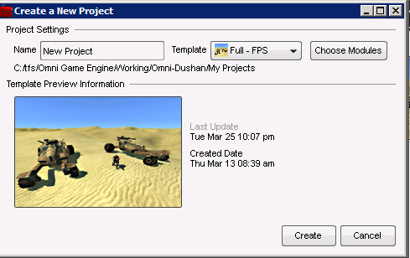

Enter a name for your new project in the “Name” text area.

Currently there are only four “Templates” available.

* C#-Full
  + This template contains all of the logic necessary to build a simple First Person shooter in C#.
* C#-Empty
  + This template is a bare-bones implementation of the engine in C#.
* TS-Full
  + This template contains all of the logic necessary to build a simple First Person shooter in TorqueScript.
* TS-Empty
  + This template is a bare-bones implementation of the engine in TorqueScript.

Click “Choose Modules”

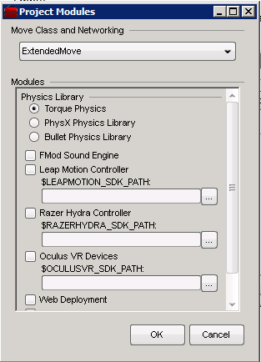

It is always recommended to use the “Extended Move” class and networking. This is required to support the latest VR headgear.

You have two choices for Physics

* Torque Physics
  + Simple Physics internal implementation
* Bullet
  + Advanced physics via the “Bullet” Library.

If you wish to support FMod, click the option.

If you are planning on using “Leap” and you have the SDK installed, check the box and select the path to the “Leap” SDK.

If you are planning on using the “Razar Hydra Controller” and you have the SDK installed, check the checkbox and select the path.

If you are planning on using the “Occulus VR Devices” and you have the SDK installed, check the checkbox and select the path to the sdk.

For this example, let’s just use the Torque Physics and the extended move class.

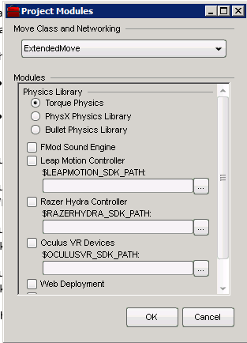

Click “OK”

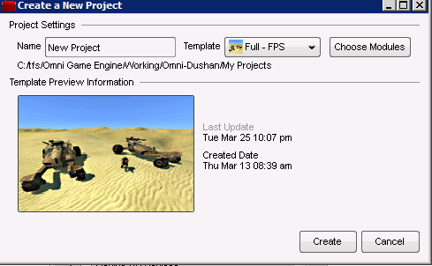

Click “Create”

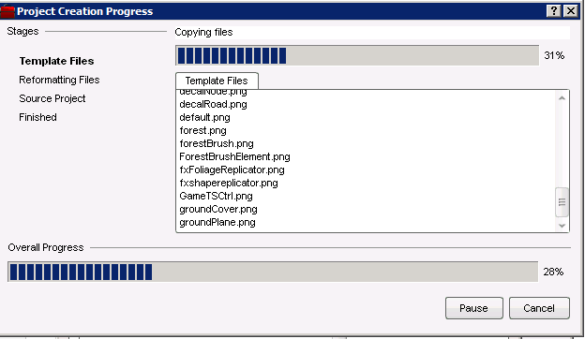

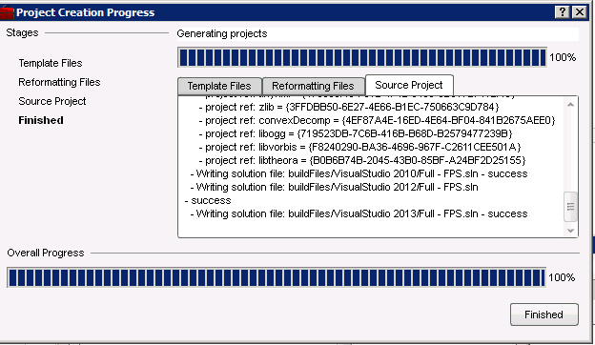

Click “Finish”

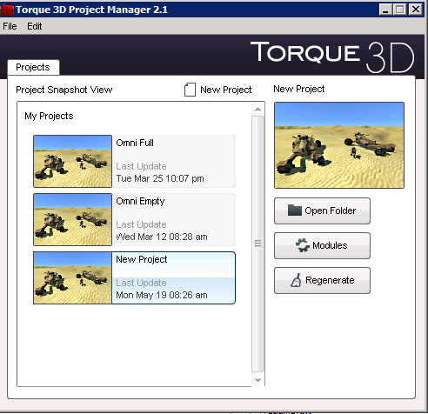

Click “Open Folder”

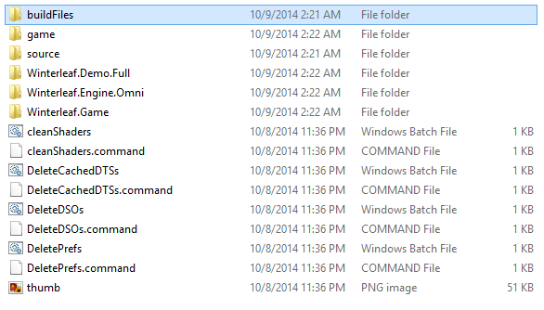

Open the folder “Build Files”

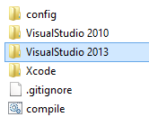

Open the “Visual Studio 2010” folder

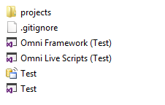

## Generated Solution Files

There are three solution files in this folder. Each solution file is used for a different purpose.

<Project Name>.sln – This is the C++ solution file.

Omni Framework.sln – Csharp game logic solution file

Omni Live Scripts.sln – Csharp runtime game logic solution file.

### Omni Framework Solution

The Omni Framework solution is comprised of three project files. Each project files fulfills a specific task. Of the three projects you will find most if not all of your work will be done in the “Model” class which is where the game logic resided. All of the projects in this solution are C#.

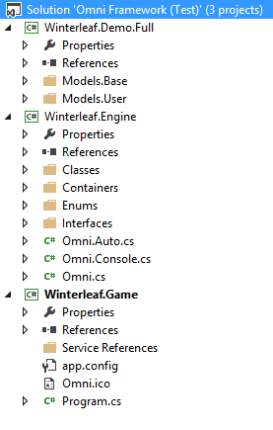

The three projects in this solution are:

* Winterleaf.Demo.Full - This project contains the business logic to your game.
* Winterleaf.Engine – This project is the Omni Framework project used to link C++ and C#.
* Winterleaf.Game – This project is the harness that generates the .exe that people will play the game with.

#### Winterleaf.Game Project

This project file is the executable game project file.

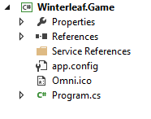

It should contain an icon for your windows and a program file. The icon is used in any simulation window created.

The other file is the C# file which actually starts everything up. A sample file:

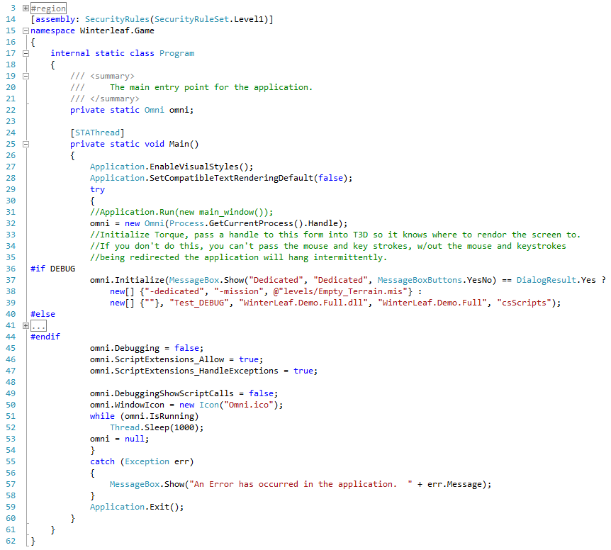

To make everything work you must create an instance of the Omni Framework. This is done on line 32 of the code.

Lines 37 through 44 are used to initialize the engine. I wrapped the code with the #if DEBUG so that it will switch the DLL’s used depending on whether you are using a Debug or Release build. The parameters required to initialize the Omni Framework are:

* Commands to be passed to the C++ DLL.
* The name of the C++ DLL
* The name of the DLL for the C# business logic for your game
* The Namespace for your C# DLL
* And optionally you can specify a directory for the engine to monitor where you can put C# scripts and edit them while the engine is running. (More on this later.)

After the Omni Framework is initialized you have several options. There are several features available inside the Omni framework that will assist you in developing your game. They are:

* Debugging – If this flag is set to true, then all interaction between the C# and C++ will be displayed in the console inside the game. This is useful when you are trying to figure out why a callback is not working.
* ScriptExtensions_Allow – This flag turns on or off the runtime compilation functionality of the Omni Framework. If this is turned on then any C# scripts in the monitored folder (Last Parameter of the Initialization function.) will be compiled any time they changed while the engine is running.
* ScriptExtensions_HandleExceptions – If this flag is enabled than any errors in the C# scripts will be caught by a wrapping Try/Catch block and the error will be displayed in the console. If this is turned off, any error in the scripts will cause a crash of the engine.  
  Try/Catch blocks consume memory and CPU time since the .Net CLR must take a snap shot of all the variables and flags prior to executing the code. Because of this, production C# should handle all possible errors without the use of Try/Catches. It is highly recommended that this feature is turned off in production games.
* DebuggingShowScriptCalls – This flag controls whether or not C++ engine callbacks will be printed in the console. Once again, very useful for debugging.
* WindowIcon – This is the Icon file which will be displayed in the window while your game is running. Currently it uses the Icon image which is flagged as “Large”.

Finally, after it is initialized we want to enter a loop and continue to loop until the Omni Framework is no longer running.

Note: Currently it is not possible to create two instances of the Omni Framework. You can with minor changes to the framework reuse an instance.

The Omni Framework can also run in a WPF window, but to stay compliant with mono our example only shows Window Forms.

#### Winterleaf.Engine Project (Omni Framework Engine)

This project contains all of the code necessary for communications between the C++ and C#. Under normal circumstances you should not need to edit the files in this project. The only time the files are updated is if you need to run the Omni Static Code Generator.

There are several folders inside this project, they are:

* Classes
* Containers
* Enums
* Interfaces

##### Classes

The class’s folder contains the C# files used by the Omni Framework.

* Dialogs.cs – Used to show file dialogs.
* arrayObject.cs – Used for providing C# syntactical access to properties of Simulation objects which are defined as Arrays inside the engine.
* ConsoleInteraction.cs – This class provides the C# decoration logic which the Omni framework looks for to determine which functions to expose to the C++ console.
* csFactory.cs – This class is used to provide run-time compilation of C# scripts.
* CustomClassDef.cs – Internal class used by the Omni Framework to manage the mapping of C# functions and provide a cached reflection of the functions.
* CustomQueue.cs – A simple Queue implementation in C# which is designed for performance.
* IndexingResult.cs – Internal class used by the engine to return the found member and global functions generated when a run-time script is compiled and exposed in the engine.
* LibraryManager.cs – Used to determine if the code is executing on Mono/C# and Window/Linux. It will use the appropriate method to set up the P/Invokes based on this information.
* MyExtensions.cs – This class provides C# Extensions for object conversion. An example would be casting a Point3F to a string and vice-versa.
* MyReflections.cs – C# doesn’t always know how to cast one type to another. This class handles all of the details of casting for the engine. C++ also has some casting that isn’t available to C#, an example of this would be casting a Boolean to a integer, the string “True”/”False” to an integer or a Boolean, etc.
* ObjectCreator.cs – This class provides a method for creating Simulation objects.
* pInvokes.cs – This class is used to manage all of the p/Invokes used by the Omni Framework and expose them to developers using the Omni Framework. It should not be edited and it is automatically updated every time the Omni Static Code generator is used.
* ProxyObject.cs - In the C++ the lowest Simulation object in the derivation tree is SimObject. In the Omni framework the lowest object is ProxyObject. It provides some base member functionality which all SimObject’s expose.
* SafeNativeMethods.cs – Every p/Invoke is declared in this file. This file is updated by the Omni Static Code generator.
* SingletonCreator.cs – Much like the object creator, but used to create Singleton objects.
* TypeConverterGeneric.cs – This template class provides type conversion helpers used by the Omni Framework to cast object types from strings.
* xmlOverrideData.cs – This class is used by the csFactory.

##### Containers

This folder contains the C# implementation of data classes implemented in the C++.

* AngAxisF – Contains an Angle, Axis X, Axis Y, Axis Z as floats
* Box3F – Contains the points in a box as floats.
* ColorF – Contains 3 floats used to determine color.
* ColorI – Contains 3 integers use to determine color.
* EaseF – No Clue
* MatrixF – Contains 3 sets of X, Y, Z coordinates of a matrix as floats.
* MatrixPositions – Contains W, X, Y, Z as floats.
* Point2F – Contains X, Y as floats.
* Point2I – Contains X, Y as integers.
* Point3F – Contains X, Y, Z as floats
* Point3I – Contains X, Y, Z as integers
* Point4F – Contains X, Y, Z, W as floats
* Polyhedron – Contains 4 Point3Fs
* RectF – Contains 2 X, Y positions as float
* RectI – Contains 2 X, Y positions as integers
* RectSpacingI – Contains Bottom, Left, Right, and Top as integers
* TransformF – Contains Orientation (X, Y, Z), Position (X, Y, Z) and Angle as floats.
* TypeCubemap – Used to handle this type defined in the C++
* TypeImageFileName – Used to handle this type defined in the C++
* TypeMaterialName - Used to handle this type defined in the C++
* TypeName – Used to handle this type defined in the C++
* TypePrefabFilename – Used to handle this type defined in the C++
* TypeSSFXAmbienceName - Used to handle this type defined in the C++
* TypeSFXDescriptionName - Used to handle this type defined in the C++
* TypeSFXEnviromentName - Used to handle this type defined in the C++
* TypeSFXParameterName - Used to handle this type defined in the C++
* TypeSFXSourceName - Used to handle this type defined in the C++
* TypeSFXStateName - Used to handle this type defined in the C++
* TypeSFXTractName - Used to handle this type defined in the C++
* TypeShapeFilename - Used to handle this type defined in the C++
* TypeStringBase - Used to handle this type defined in the C++
* TypeTerrainMaterialName - Used to handle this type defined in the C++
* Vector – The C++ engine supports three types of vectors. (Integer, Float, and Boolean) This class simplifies accessing them via C#.

##### Enumerations

This folder contains the enumerations exposed in the C++ console in C#.

* domUpAxisType – Enumeration for the TSStatic maskbits.
* GuiGraphType – Graphic enumeration.
* SceneObjectTypes – All object type masks in the engine.
* T3D_Enums – This file is generated by the Omni Static Code Generator. It exposes all of the C++ console types in a format that is friendly with C#.

##### Interfaces

This folder holds all class interfaces used in the Omni Framework.

* iEnum – An enumeration which all custom enumerations support for automation inside the Omni Framework.

##### Remaining files in the Winterleaf.Engine

* Omni.Auto.cs – This file is autogenerated using the Omni Static Code Generator. It contains the wrappers for all the P/Invokes inside the engine.
* Omni.Console.cs – This file contains custom implementations for getting/setting values inside the engine. This code is pretty static and is not regenerated when the Omni Static Code Generator is run.
* Omni.cs – The heart of the Omni Framework, this file is the coordinator for all objects and management of the Omni C++ DLL. It contains the logic for passing data back and forth between the C++ and C#.

#### Winterleaf.Demo.Full or Winterleaf.Demo.Empty

This project contains the unique business logic that runs the game. It is completely object oriented. There is a base file and folder structure that is required for the project to work with the Omni Framework.

### <Project Name>.sln Solution

This solution is Winterleaf Entertainment’s branch of the MIT T3D engine SDK. Full documentation on this solution can be found at <http://www.garagegames.com>. This solution contains all of the C++ source code used in the rendering engine which the OMNI Framework encapsulates.

After you create your own project and open this solution you will see a project called “<Project Name> DLL” This C++ project is the branched C++ MIT T3D Engine code.

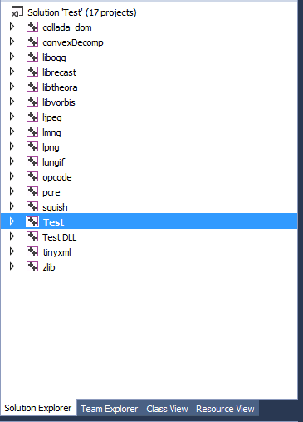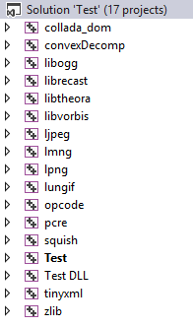

If you are planning to use C#, you can unload or turn off building the standard T3D exe project since it won’t be used.

To do this, right click on the “Test” project and click “Unload”.

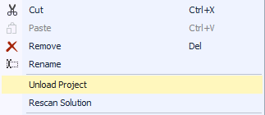

After clicking “Unload” the project should look like the picture below.

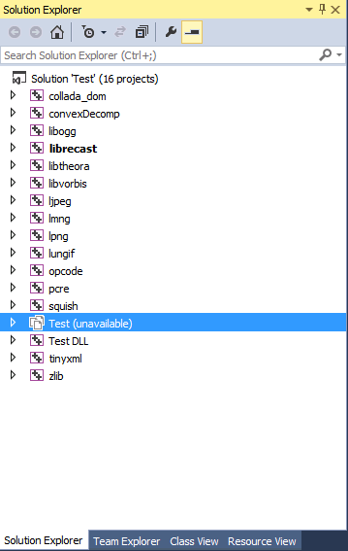

If you do not wish to unload the project, you can alternatively turn off the Build of the C++ Executable via the Build Configuration.

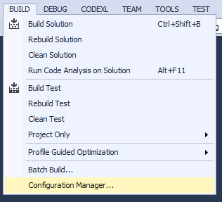

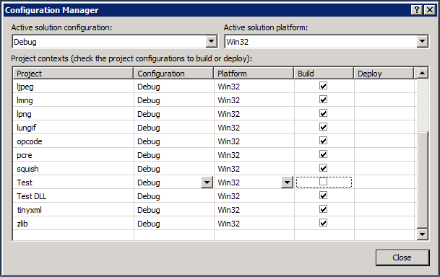

Uncheck the checkbox next to the C++ executable project.

### Omni Live Scripts Solution

The only project in this solution is “Winterleaf.Demo.LiveScripts”. The purpose of this solution is to simplify and provide intellesense for writing code which can be re-compiled while the engine is running so that you do not have to stop and restart the engine every time you wish to fix something.

There are three examples of how live scripts work in this project.

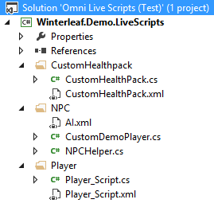

The three examples are:

* Extending the Player Object (coPlayer folder)
* Creating a custom “HealthPack” proxy object based off of the stock “HealthPack” (CustomHealthpack folder)
* A custom “NPC” proxy object based off the base “NPC” object. (NPC Folder)

The files are not compiled into a DLL and included in the engine at run-time, but instead they are read by the engine at run-time and are compiled into in-memory types. These types can then be used just like any other object except they can be recompiled in memory at any time by just re-saving the source code or XML.

## Static Code Generator - Update the Omni Framework Code

This section will discuss how you update the Omni Framework C# and C++ code. This process needs to be repeated every time you modify the C++ MIT T3D project.

For more advanced usages of the Omni T3D Engine you will find that you have to modify the C++ MIT T3D code base. This could be for many reasons including adding a new SimObjects, console functions, etc. Sooner or later at some point you will need to dig into the C++ code to customize it for your particular game.

When this happens, if you do not re-run the Static Code Generator, your C# proxy objects will become out of sync with the C++ objects. This program parses the entire MIT T3D engine source code and extracts information about the objects, variables, intellesence, enumerations, etc.

The Static Code Anaylzer WILL NOT overwrite your custom code, the code has been structured in a format so that it can be regenerated at any time without modifying/erasing custom logic you added to the C# Game Logic Project (Controller).

This program is provided in two formats, one is a standalone application and the other is a Visual Studio extension. Both of which are installed during Chapter 2.

**Important: If you are using the “Free” versions of Microsoft Visual Studio, you will need to use the stand-alone version of the Static Code Analyzer.**

## Static Code Generator (Visual Studio Extension)

This section explains how to use the Visual Studio Extension provided by Winterleaf Entertainment to run the Static Code Generator Visual Studio Extension.

### Step 1, Check out the source code (if applicable)

If you are using a source control plugin such as Microsoft Team Foundation Server or any other Source Control solution which makes the files read-only, you must check out the entire **“engine\source”** folder. The Static Code Analyzer will not only need to read these files but also append code to the end of them.

If you are using the stand-alone version of the Static Code Analyzer you will also need to check out the following folders in the game folder:

* **“My Projects/<Game Name>/Winterleaf.Demo.Full”**
* **“My Projects/<Game Name>/Winterleaf.Engine.Omni”**

### Step 2, Open the “Omni Framework Solution”

Go to the **“c:\Omni\My Projects\<Game Name>\buildFiles\VisualStudio 2010”** folder

Open the solution **“Omni Framework.sln”**

### Step 3, Open the Static Code Generator Extension

You will find the button on your Visual Studio toolbar right after the test option.

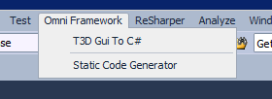

After clicking the button you will see the following tool window.

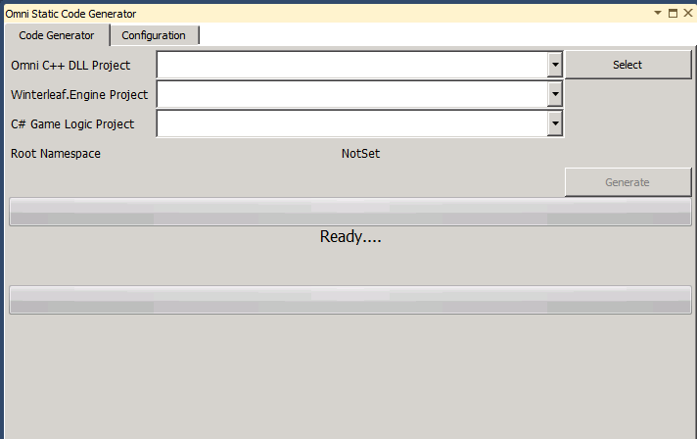

### Step 4, Select the Omni C++ DLL project

The first thing you must do is open the MIT T3D SDK solution file.

To do this, click “Select”, and then pick the <Game Name> solution file.

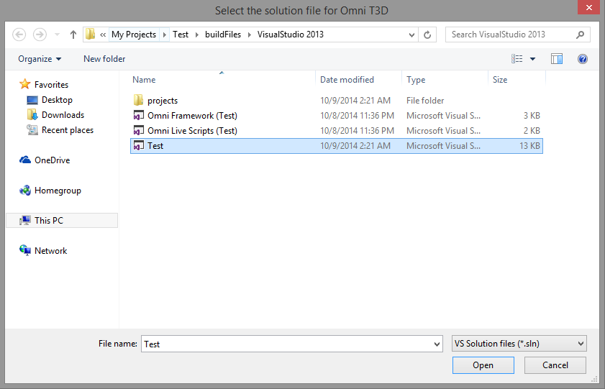

Click “Open”.

### Step 5, Select the C++ DLL Project

In the “Omni C++ DLL Project” dropdown select the project that is named “<Project Name> DLL”.



### Step 6, Select the Winterleaf.Engine project.



### Step 7, Select the C# Game Logic Project



### Step 8, Review the configuration

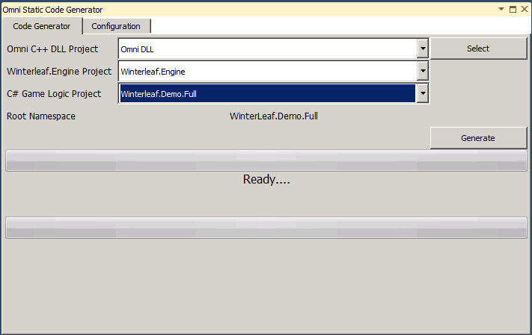

It is important, that the “Root Namespace” is correct. An incorrect “Root Namespace” can cause the game to appear to not work since the Omni Framework uses a great deal of reflections to achieve its functionality. So if you create your own C# Game Logic project, make sure the “Root Namespace” in the project properties match the “Root Namespace” in your C# code.

#### C# Project Properties

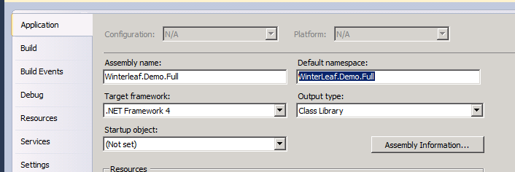

#### Sample Code File

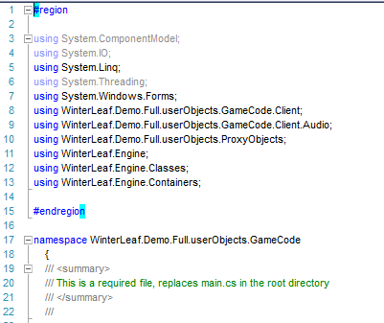

### Step 9, Click “Generate”

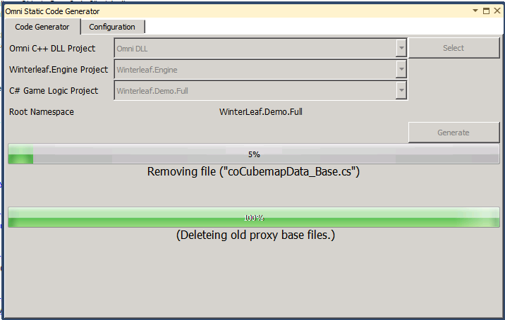

The first thing the Static Code Generator will do is remove all of the old generated code from the project to prevent artifacts carrying over from major C++ changes. Once this is complete, the Static Code Generator will read the C++ source code and generate all of the necessary C# files.

If the code generator experiences an error, a message will be displayed on screen and the detail of the error will be in the job log text file which pops up after the Static Code Generator completes.

### Step 10, Recompile

You will need to recompile the following solutions:

* <Project Name>.sln
* Omni Framework.sln

## Static Code Generator (Stand-Alone)

This section mainly applies to programmers who are using the “Free” version of Microsoft Visual Studio, or just prefer to run stand-alone applications.

### Step 1, Check out the source code (if applicable)

If you are using a source control plugin such as Microsoft Team Foundation Server or any other Source Control solution which makes the files read-only, you must check out the entire **“engine\source”** folder. The Static Code Analyzer will not only need to read these files but also append code to the end of them.

If you are using the stand-alone version of the Static Code Analyzer you will also need to check out the following folders in the game folder:

* **“My Projects/<Game Name>/Winterleaf.Demo.Full”**
* **“My Projects/<Game Name>/Winterleaf.Engine.Omni”**

### Step 2, Start the Static Code Generator (Stand-Alone)

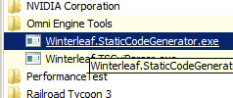

### Step 3, Click “Select Omni T3D Solution File”

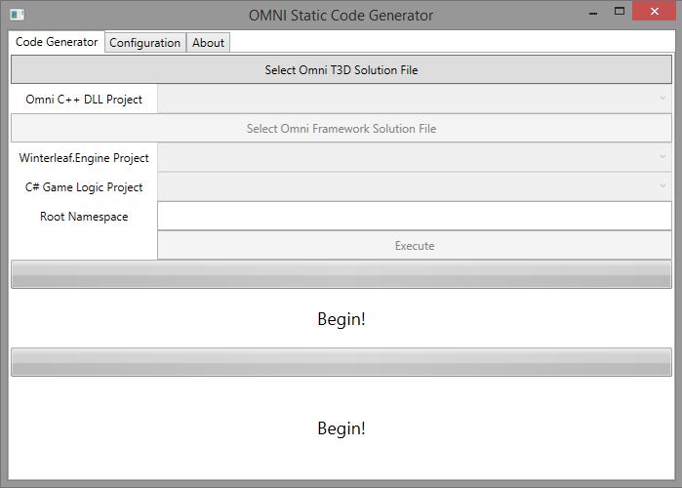

### Step 4, Select the “<Project Name>.sln” file.



Click “Open”

### Step 5, Click “Select Omni Framework Solution”

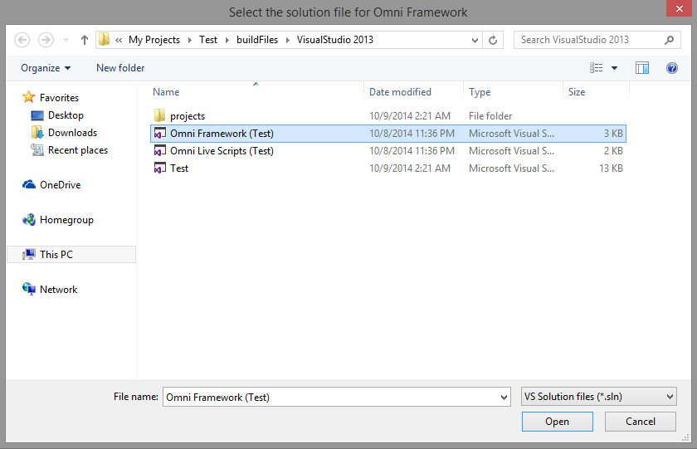

Select the “Omni Framework.sln” file.

Click “Open”.

### Step 6, Select the C++ DLL Project

In the “Omni C++ DLL Project” dropdown select the project that is named “<Project Name> DLL”.



### Step 7, Select the Winterleaf.Engine project.



### Step 8, Select the C# Game Logic Project



### Step 9, Click “Execute”

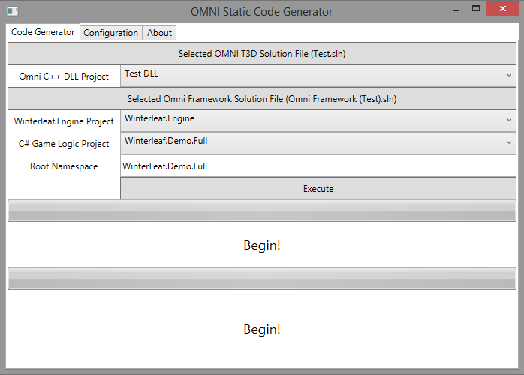

### Step 10, Wait for the Static Code Generator to finish.

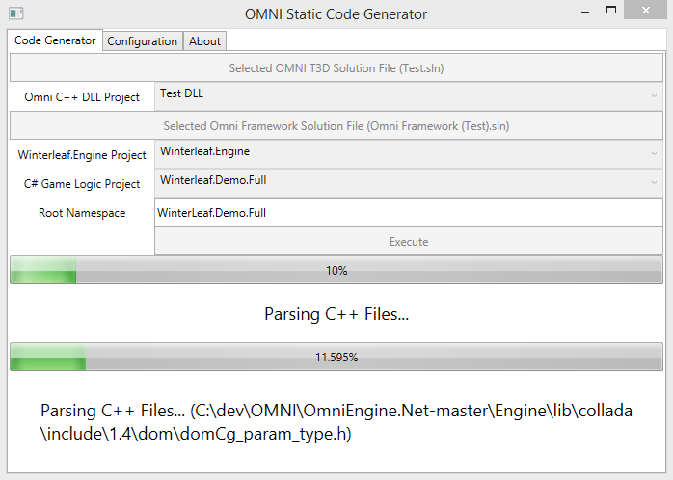

### Step 11, Add new files to the “C# Game Logic Project”

The stand-alone application does not have the ability to modify the project files to add new classes to it. Because of this you must open the project up and manually add any new class files which might have been generated.

To do this, open the “Winterleaf.Demo.Full” project and have it show all files.

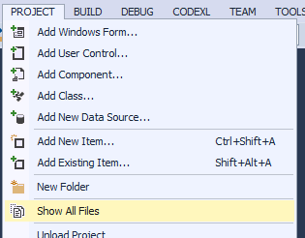

New files generated by the Static Code Generator will appear grayed out.

**Note: If you haven’t added any new SimObject C++ types to the engine, then there won’t be any greyed out files.**

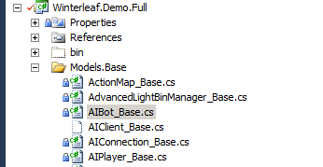

Right click the file and click “Include in Project”

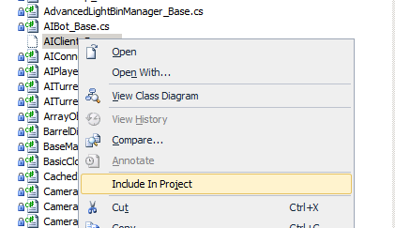

Repeat this process for all the grayed out files in the “Models.Base” folder.

Next go to the “Models.User/Extendable” folder and repeat the process.

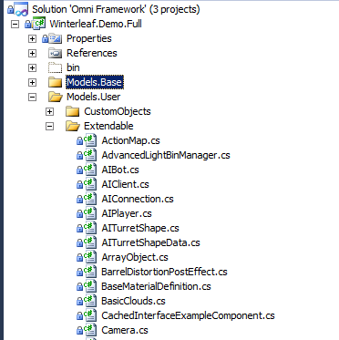

### Step 12, Recompile

You will need to recompile the following solutions:

* <Project Name>.sln
* Omni Framework.sln

For more information including how to extend the Static Code Generator to handle custom code please see Appendix 1.

## Running the Game

Now that the files are up to date you are able to run the game. Open up the “Omni Framework.sln” solution and right click the “Winterleaf.Game” project. In the menu, pick “Set as Startup Project”.

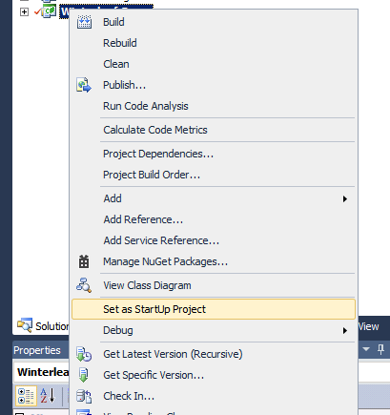

Finally, click “Debug”->”Start Debugging”

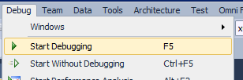

Congratulations, you have created your first project!

# Chapter 4 Customizing Winterleaf.Game Executable Name

At this point we assume you have created a new project and it has compiled. Now begins the time of customizing the Game Executable to your game information.

So open the “Omni Framework” solution.

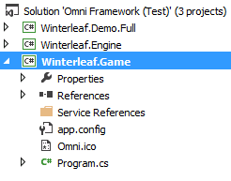

Right click on the “Winterleaf.Game” project and select “Rename”



For this example, we will call our new executable “URGame”.

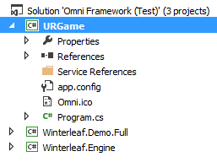

Now, we must configure the Properties for this project to reflect the renaming of the project. So once again right click on the “URGame” project and select “Properties”.

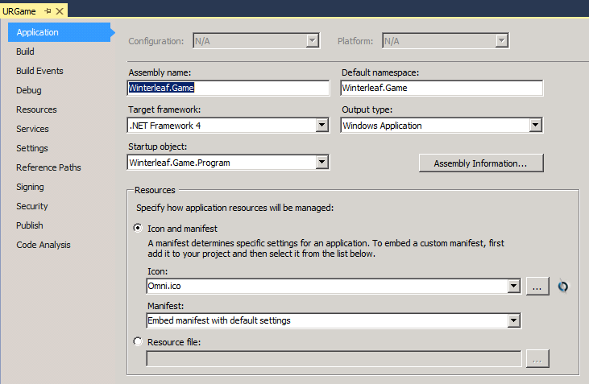

As you can see, the Assembly name is still “Winterleaf.Game”, we need to change this to “URGame”. By changing this property we are changing what the compiler will name the executable.

I would also highly recommend changing the Default Namespace for the project as well. Something to keep in mind, it is best to use the same base namespace name for both the Business Layer and Game Executable. So in this example, we will make the default namespace for the “URGame” executable be “MyCompany.URGame.Executable”.

You will also notice that we can select the Icon for the game here as well.

When we finish, it should look like the image on the next page.

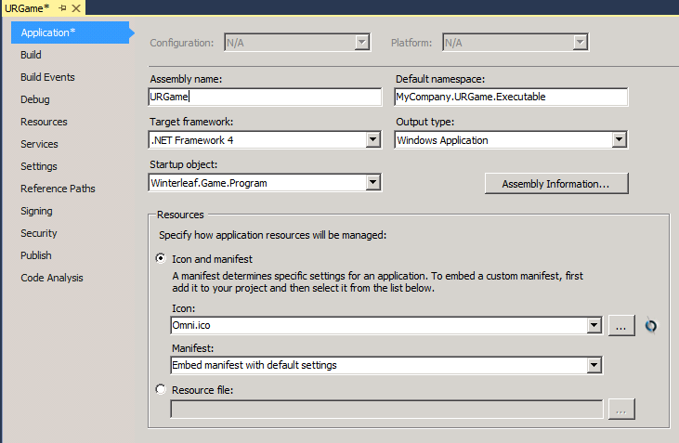

Now that we have updated the Project’s properties, we need to update the source code in the project to reflect our namespace change.

Open the source code to “Program.cs” and highlight “Winterleaf.Game” like the image below.

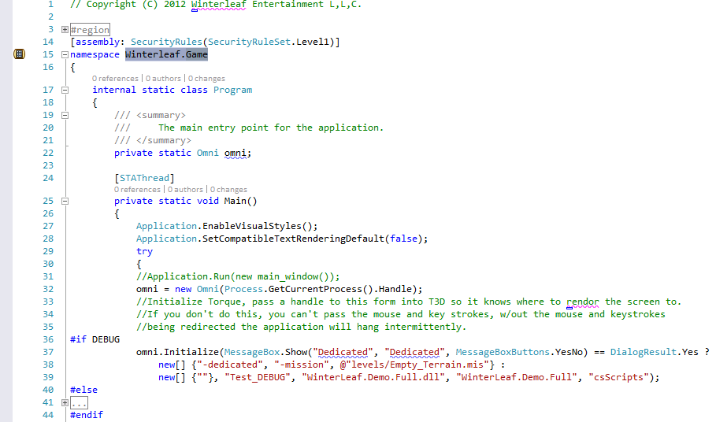

“Winterleaf.Game” is the old namespace for the program, we need to update this with our new namespace “MyCompany.URGame.Executable”.

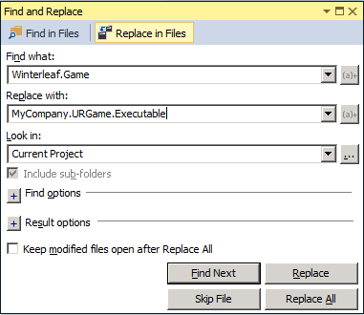So to do this, press <ctrl><alt><f>. “Winterleaf.Game” should be selected for “Find What” and type into “Replace with” our new namespace of “MyCompany.URGame.Executable”.

IMPORTANT: Make sure the “Look in” is set to “Current Project”. We aren’t ready to replace the namespaces in the other projects yet.

Press “Replace ALL”.

Now that we have replaced the namespace we need to update the Projects Properties one more time. The Project Properties should look like the image below.

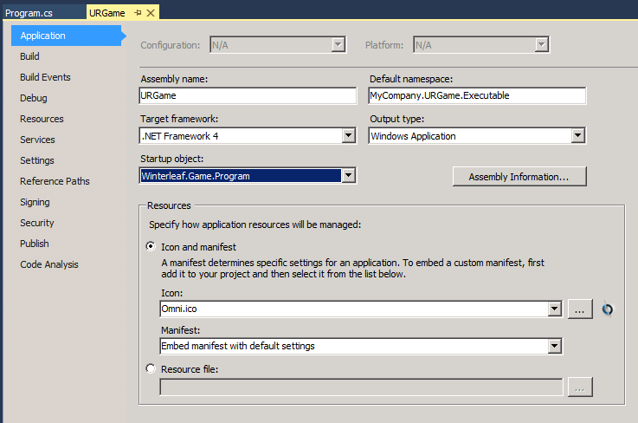

We need to change the “Startup Object” from “Winterleaf.Game.Program” to our new namespace, “MyCompany.URGame.Executable.Program”.

After changing the drop down it should look like the image below.

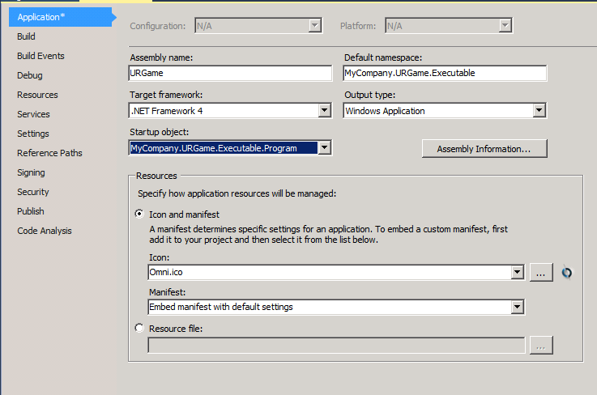

Congratulations! You have successfully customize the Game Executable to your game needs.

# Chapter 5 Customizing Winterleaf.Demo.Full

It is assumed at this point you have already customized your Game Executable project and you are now eyeing the “Winterleaf.Demo.Full” project. There is no reason you can’t change the name to be more reflective of your own game, this chapter will address how to customize it to your project.

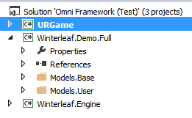So starting with the Solution Explorer, if you are following the examples, it should look like the image below.

Just like in the previous chapter, the first step is to rename “Winterleaf.Demo.Full” to something more fitting for your game. Our first step is to right click on the “Winterleaf.Demo.Full” project and select “Rename”.

We will rename it to “MyCompany.URGame.Logic”.

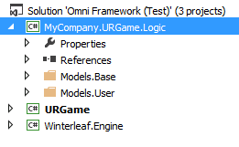After renaming the project our solution explorer should look like the image to the right.

After renaming the project we now need to update the projects namespace. This process is identical to the process in the previous chapter.

So, right click on “MyCompany.URGame.Logic” and go to properties.

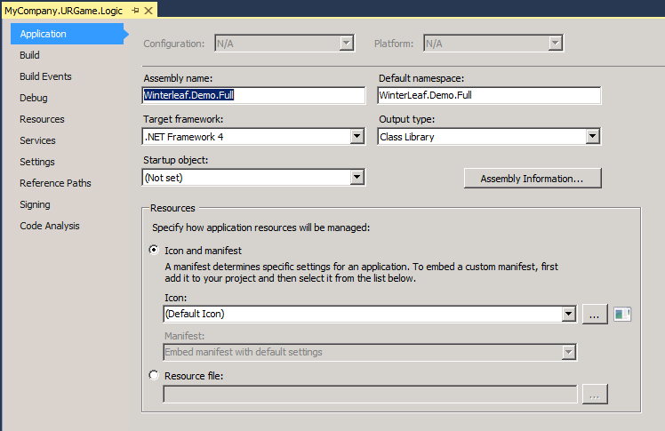

First we need to change the assembly name and Default namespace to “MyCompany.URGame.Logic”. Once you change it, it should look like the image below.

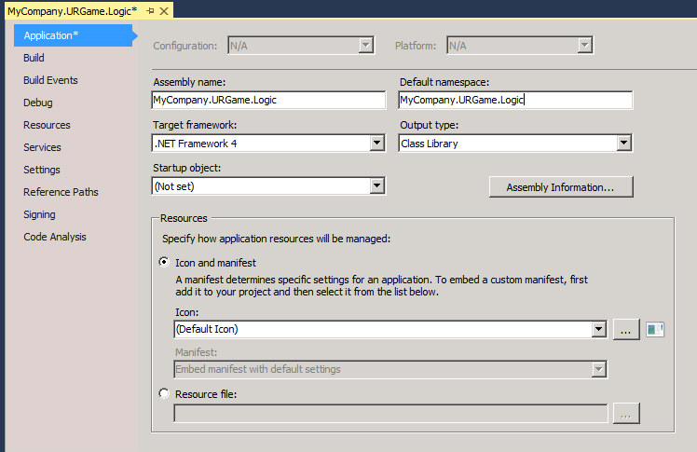

Now that we have updated the project properties, we need to update all the C# to use our new Namespace.

To do this we need to open up one of the C# files inside our project, in the image below I choose “ActionMap_Base.CS”. 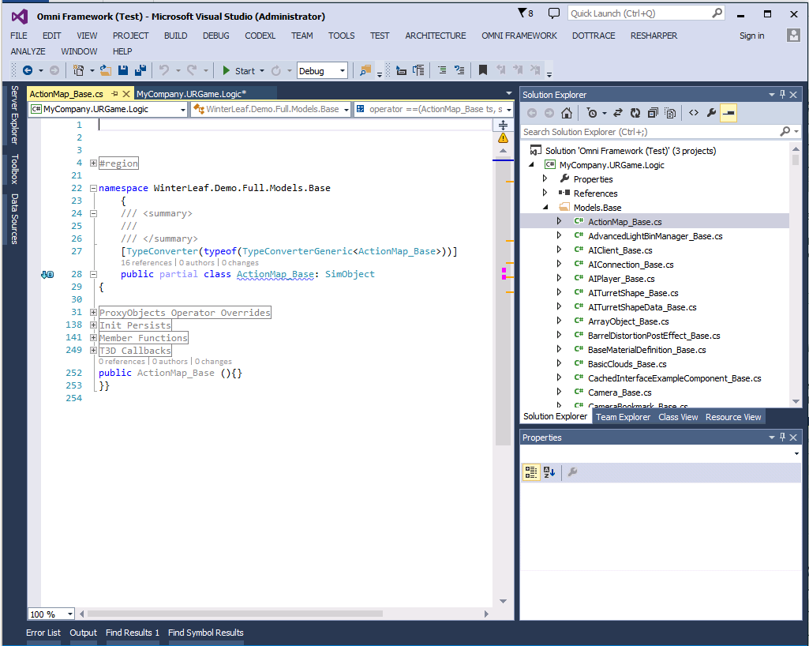

Highlight “Winterleaf.Demo.Full.” and press <Ctrl><Alt>F.

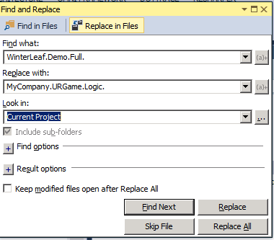The find and Replace window should look like the image to the right. Make sure when you type your new namespace you end it with a period. So we are replacing “Winterleaf.Demo.Full.” with “MyCompany.URGame.Logic.”.

Make sure the “Look in” is set to “Current Project”.

Press “Replace ALL” when all fields are filled in.

It will then begin replacing the namespace in all the files, this can take some time, so go get a fresh cup of coffee.

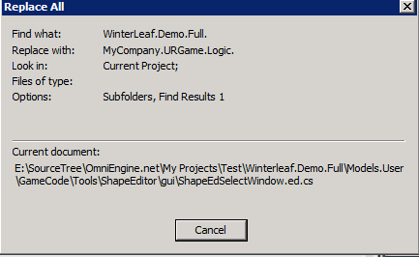

After it completes we just need to update the Game Executable with the new information. So open up the “Program.cs” file in the “URGame” project.

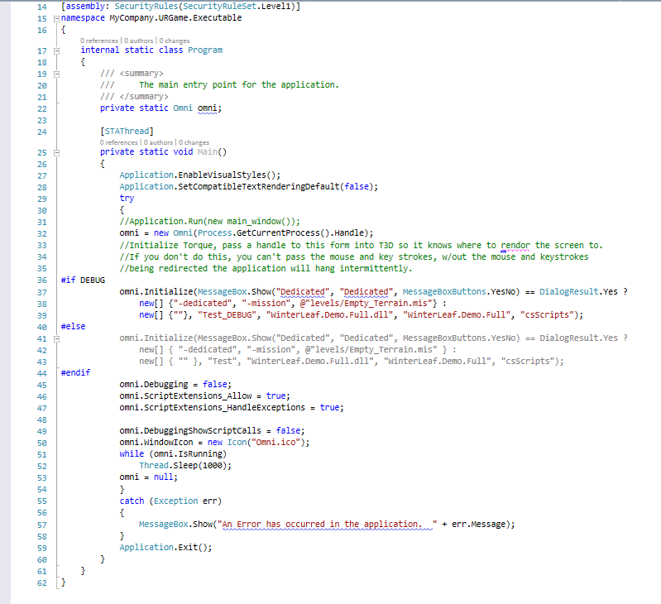

Specifically, we are looking at the code on lines 37 to 44. These lines configure the OMNI Framework initialization values.

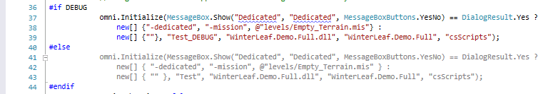

Looking at the code above, you can see that the old DLL name being used was “Winterleaf.Demo.Full.dll” and the old namespace was “Winterleaf.Demo.Full”. We need to update these values to reflect the new names we assigned.

So replace “Winterleaf.Demo.Full.dll” with the new name you assigned the DLL. In this example it is “MyCompany.URGame.Logic.dll” and then change the Namespace to “MyCompany.URGame.Logic”. Make sure you change it on both lines 39 and 43.

Go to your game directory and delete all the exe and dll’s, we will need to regenerate them. Your folder should be similar to the image below.

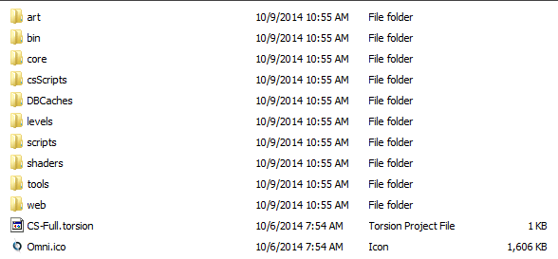

Now, rebuild both solutions. After rebuilding your game folder should look like the image below.

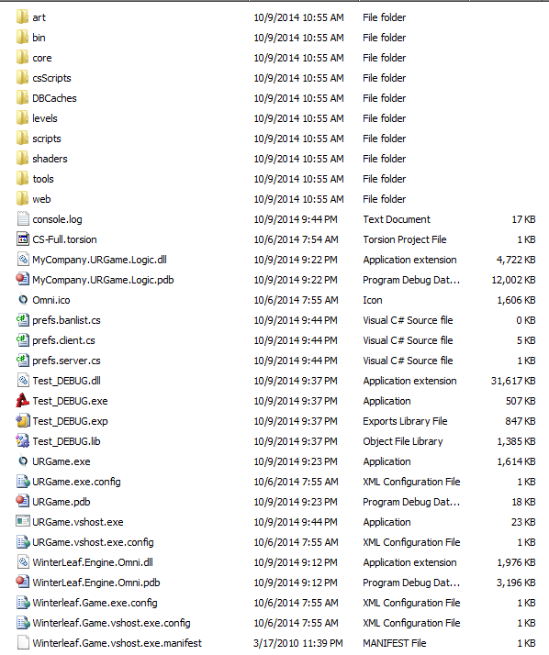

Run the URGame.exe to fire up your customized game!

# Chapter 5 Object Models Overview

## Introduction

All Objects Models in the OMNI Framework are derived from the BaseModel class found in the namespace “WinterLeaf.Engine.Classes”. The BaseModel provides a foundation for all objects derived from it. Its functionality is limited to subset of functions found on SimObject.

General Inheritance Design

The inheritance structure was specifically designed to be used in conjunction with a code generator. A sample of the inheritance tree is:



The above doesn’t represent all the classes in the engine, but instead demonstrates how the inheritance is modeled.

## Reasoning

All of the base functionality exposed by the C++ object is incorporated into the “_Base” class. This would include member functions and member variables. These would be combined with the inherited member functions and member variables of the parent classes. In the event that in the C++ a member function was overridden and redefined, you would have to use the C# syntax of “base.somefunction()” to call the hidden function.

When you want to add custom code to a Base Model, you simple create a partial class of the Extendable class. This design puts the custom C# code in a separate class file from the “_Base” and “Extendable” class. That way when the code generator is re-executed, none of the custom code added to the class is overridden.

The Static Code Generator will automatically empty the folders “Models.Base” and “Model.User/Extendable” every time it is run. Because of this it is not recommended to save your class extensions to the Extendable classes in the “Model.User/Extendable” folder in the project.

In the example code provided in the “WinterLeaf.Demo.Full” project you will see that all partial class extensions for the “Extendable” objects are stored in various places inside the “Model.User/GameCode” folder. Where it is saved is not important, the only thing that is important is that the partial class namespace matches the namespace of the partial class defined in “Model.User/Extendable” class.

# Chapter 6 Creating Views (Omni T3D Objects)

## Introduction

Due to the different types of Views (Omni T3D Objects) available in the game there are different ways to create each of the View (Omni T3D Object) and in some cases multiple ways to create that View(Omni T3D Object).

An important thing to remember is that everything in the Omni T3D Engine is an object: players, vehicles, items, etc. It is the purpose of the objects that determine what sub-type of object they are.

To begin with, there are three different types of View types. This can get confusing and more information about the different types of objects can be found at <http://docs.garagegames.com/torque-3d/reference/syntaxGameObjects.html>.

The View Types are:

* Instance based View (Omni T3D Instanced Objects)
  + Create() function returns the uint handle to the new object.
* Datablock
  + Create() function returns the name of the new datablock.
* Singleton
  + Create() function returns the name of the new singleton.

## There are three rules that apply to all Creator Types:

### Rule 1: You cannot assign properties after you call the “Create()” function.

Once the “Create()” function is called you cannot assign more properties.

### Rule 2: Any Creator based object being assigned as a property, the property must be prefixed with a “#”.

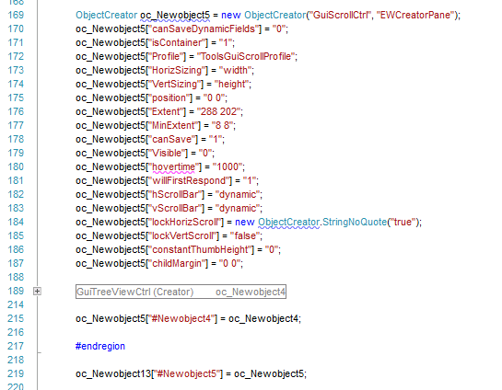

As you can see in the above code snippet, the assignment of an Object Creator is assigned to a property prefixed with “#”. The name of the property must be unique.

### Rule 3: All Creator based objects assigned as properties must be the last properties assigned.

As you can see in the above code snippet, the assignment of an Object Creator must be last in the list of properties.

## ObjectCreator Class: Create Instanced based Views

Most of the Views you create using the Omni T3D Framework will be of this type. This includes players, game items, vehicles, etc.

In the simplest form, a View can be created with one line of code:



This single line of code would create a new “GuiCanvas” View called “Canvas” and bind it to the “canvas” C# model.

The exact syntax for using the ObjectCreator is:



* “ClassName” is the name of the Omni T3D Object.
* “InstanceName” is a friendly name you want to assign to the object.
* “model” is the c# class type which an instance will be created for when the object is created.

You can also specify properties along with specifying the Class Name, Instance Name and Model. 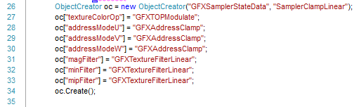

The above code shows how to add initial values to properties on the object. The values provided for the properties can be simple strings or complex objects.

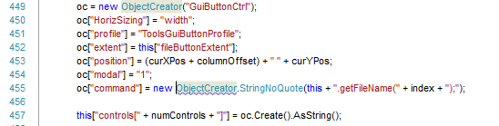

Any object which can be serialized to a string via “toString()” can be assigned as a value to a property. Also, you can specify friendly names of other objects as the value to a property. You can even go so far as to nest Creator based objects inside of other Creators as seen on line 455.

The key here is that after you assign the properties to the View you call the Create() function to create the View. The Create() function will then return to the caller the ID of the View in the world which you can use as a handle.

You will find that Gui’s use extensively nested ObjectCreators. This is because we want to create a TextBox inside a panel that is inside a Scrollable area which is inside a window. The important thing to remember is that the order of everything is very important.

## DatablockCreator Class: Create Datablock based Views

When creating Instance based Views in the Omni T3D engine you will want to assign static values. These static values are saved in Datablocks. Datablocks are only transmitted once to the client when the client connects to the server. Use of Datablocks reduce the network traffic to all clients.

The exact syntax for using the ObjectCreator is:



* “ClassName” is the name of the Omni T3D Object.
* “InstanceName” is a friendly name you want to assign to the object.
* “model” is the c# class type which an instance will be created for when the object is created.

You can also specify properties along with specifying the Class Name, Instance Name and Model.



The above code shows how to add initial values to properties on the object. The values provided for the properties can be simple strings or complex objects.

Any object which can be serialized to a string via “toString()” can be assigned as a value to a property. Also, you can specify friendly names of other objects as the value to a property. You can even go so far as to nest Creator based objects inside of other Creators as seen on line 455.

The key here is that after you assign the properties to the View you call the Create() function to create the View. The Create() function will then return to the caller the ID of the View in the world which you can use as a handle.

## SingletonCreator Class: Create Singleton based Views

If you need a global script object with only a single instance, you can use the singleton keyword. Singletons, in TorqueScript, are mostly used for unique shaders, materials, and other client-side only objects.

For example, SSAO (screen space ambient occlusion) is a post-processing effect. The game will only ever need a single instance of the shader, but it needs to be globally accessible on the client. The declaration of the SSAO shader in C# can be shown below:

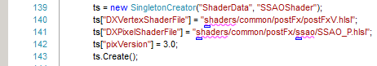

The constructor is:



* “ClassName” is the name of the Omni T3D Object.
* “SingletonName” is a friendly name you want to assign to the object.
* “model” is the c# class type which an instance will be created for when the object is created.

You can also specify properties along with specifying the Class Name, Instance Name and Model.

The above code shows how to add initial values to properties on the object. The values provided for the properties can be simple strings or complex objects.

Any object which can be serialized to a string via “toString()” can be assigned as a value to a property. Also, you can specify friendly names of other objects as the value to a property. You can even go so far as to nest Creator based objects inside of other Creators as seen on line 455.

The key here is that after you assign the properties to the View you call the Create() function to create the View. The Create() function will then return to the caller the ID of the View in the world which you can use as a handle.

## Creating Objects in TorqueScript

Sometimes some code will make more since to be left in TorqueScript than to convert to C# during development. Datablocks are the biggest offender since artists may want to swap out animations, file references and such while they are working on assets. Forcing them to have Visual Studio and to recompile the code every time they want to change something could be cumbersome.

Because of this, you can hook a Model up to any object via TorqueScript with one simple property.

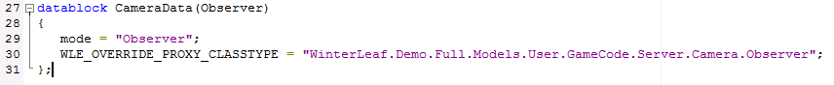

This is done by using the property “WLE_Override_Proxy_ClassType”.

This property states the full namespace to the Model this object will use when it is created. Obviously for code management this is not the recommended way doing it, but it does provide a work-around when you have a situation where a TorqueScript/C# combination environment going on.

If you do not specify the WLE_Override_Proxy_ClassType Model in the properties, the default Model will be used when the Omni T3D View is created. So in the case above, if the Observer Model had not been specified, it would have used the Model “CameraData”.

# Chapter 7 Extending the User.Models.Extendable

This section will explain how to take the base code and extend them. To create your game you will need to override and create new functions and member variables in the Extendable Models. This would include adding generic logic for collisions, object addition/removal, mounting, etc.

A couple of things to remember!

* Callbacks from the T3D engine are already exposed in the base class, so to add logic for one of them you just need to override the function.
* If you plan to allow a custom function to be re-implemented in an inherited class, the function must be defined as “virtual”.
* Functions that are not callbacks from the T3D engine that you wish to be callable from the T3D console must be marked with the “ConsoleInteration” decoration.
* Extended Models are always defined as a **“public partial class”**.

## Member Functions (Overriding T3D engine Callbacks)

This is just the process of overriding the intended public function to the class. In the class file located at Model.User/GameCode/Server/Player/PlayerData.cs file you will see the following code.

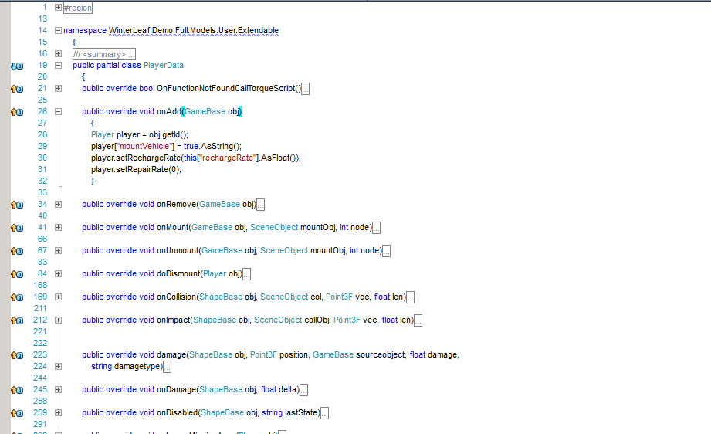

Take notice that the class Namespace is not reflective of where the file is. This is because you must store your partial class extensions to “Extendable” classes in a different folder than the “Extendable” location.

Next you will notice that each function starts with “public override…” Each of the functions defined in this partial class are defined in either the “_Base” of this model or a parent model all the way to the “ModelBase” model. On line 28 you can see where custom code for the “onAdd” callback has been added to the class. Whenever a View (T3D Object) has an “onAdd” event, the event will be rerouted to this Model class and the “onAdd” member function will be called. This is the same for all of the overridden member functions.

## “ConsoleInteraction” Decoration

There are times when you will want to add a new member function to a Model and have it callable via the console inside of the T3D engine. Usually these are times when you are using the old style of Gui interface event wiring. Other times, you might want to expose a function to the console for debugging purposes. No matter what the reason, any function can be exposed to the T3D console using the “[ConsoleInteraction]” decoration placed before it.

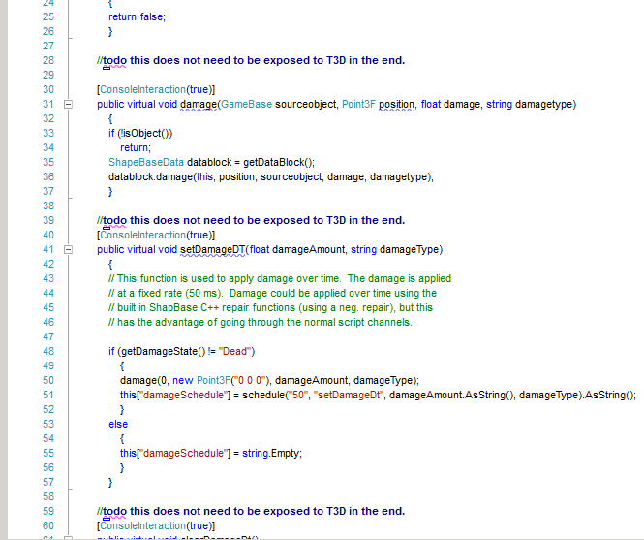

In the example code above, you can see how the “damage” and “setDamageDT” member functions are being exposed to the T3D console. (You can bring up the T3D console when the game is running by pressing the ` key.

## Member Variables

When defining variables in your code you have two options. You can go the traditional route and use the View[“variable name”] method or you can define a property in the cSharp. You can also combine the two to create programming shortcuts.

### Traditional Member Variable



What this is doing is creating a T3D member variable for object “this” called “damageSchedule”. This variable is accessible from both C#, TorqueScript, and the console since it lives in the Omni T3D Engine. Omni T3D will manage the variable and clean up and the memory space the variable uses is reserved in the un-managed memory area of the application.

### C# Member Variable

A C# member variable would be defined in the C# like the following.



And

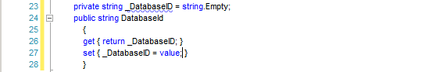

Both are the same except one uses a backer variable and the other doesn’t. The C# member variable is only stored in the C# and is not exposed to the Omni T3D engine. It is persisted for as long as the object exists, so it is state-full. It cannot be accessed via TorqueScript or the console. The memory is stored in the managed memory area of the application.

### Hybrid Member Variable

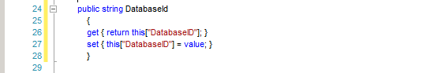

In this case we are using the “Traditional Memory Variable” memory storage and access with the ease of the “C# Member Variable” format. This simplifies the c# coding and reduces the changes for errors while still exposing the member variable to the console.

**NOTE:**

**All of the member variables defined in the “InitPersist” C++ code block are exposed to the C# using the Hybrid Member Variable format automatically casted to the appropriate mapped C# class type derived from the C++ code.**

### Static Member Functions (Global functions)

Any function that is defined as static and has a ConsoleInteraction decoration is assumed to be a global function inside the Omni T3D engine regardless of where it is defined. Because of this, all static functions must have a unique name and the unique name is not case-sensitive.

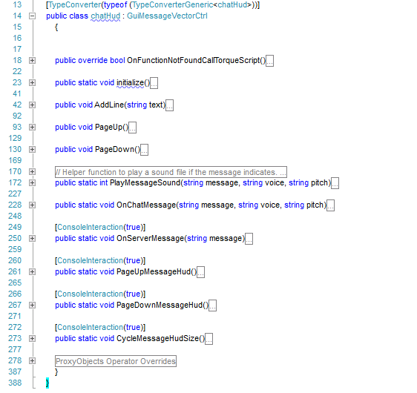

In the above code on line 228 you will see there is a static member function “OnChatMessage”. Even though this static function lives inside the chatHud Model the function is a global function. This allows you to group T3D Global console functions in the Models that they pertain to or just create a static c# class that has generic global Omni T3D function calls in it.

## Function: OnFunctionNotFoundCallTorqueScript

All C# Models have the “OnFunctionNotFoundCallTorqueScript” either via inheritance from the base model or overridden in the class definition. By default this function returns true.

This function is called whenever the T3D engine calls to the Omni Framework and the Omni Framework is not able to find the function defined in the C#. If this function returns true, then the Omni Framework will pass control back to the C++ engine and have it check if the function exists in a TorqueScript file. If the function exists in a TorqueScript function, it will call the function and continue processing.

Calling TorqueScript is very expensive, so to improve performance we provided this method as a way to shortcut the engine. When you have finished converting a class from TorqueScript to C# it is always recommended to override this function and have it return false.

# Chapter 8 Custom Models

A custom model is a model which is derived from an “Extendable” model where the goal is to override or extend functionality thus creating a completely new Model based on an “Extendable” one.

An example of a Custom Model is the DemoPlayer class located at User.Models/GameCode/Server/AI.

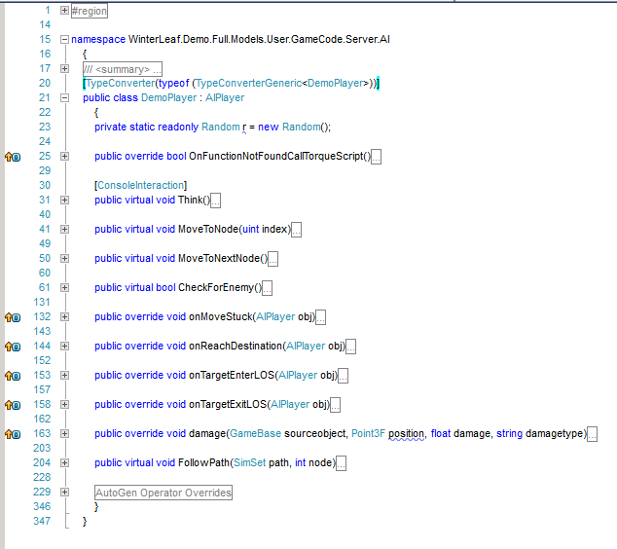

This class derives from AIPlayer which is a base model. In this case we are redefining how any View (T3D AIPlayer Object Instance) assigned to this model will behave by telling the Omni Framework not to use the AIPlayer class but instead the DemoPlayer class.



The above code is needed for casting and conversion. This decorator automatically creates a TypeConverter for your custom object.

Also needed for proper operation is the code defined in the “AutoGen Operator Overrides”

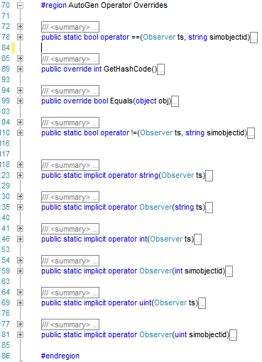

Every custom Model you create must have these functions implemented so that the Omni Framework can properly cast your model to a string and other Model types. For the most part, you can just copy the code from an existing class and paste it in your new class and just change the type to the type of your new Model.

There are times when you would want to create class(s) which derive from DemoPlayer. Assuming that DemoPlayer has all the base movement and combat code in it, we would create a new class which inherits from DemoPlayer but changes how it picks targets, (Let us call it TargetDemoPlayer). So when creating an AIPlayer View we would have 3 options for Models.

* AIPlayer – The default model assigned if none is specified.
* DemoPlayer
* TargetDemoPlayer

All three models could be casted down,

* TargetDemoPlayer could be casted down to a DemoPlayer and AIPlayer and lower.
* DemoPlayer could be casted down to an AIPlayer and lower.
* AIPlayer could be casted to anything lower.

This functionality gives us the ability to re-use an Omni T3D View Object, but assign different behavior sets by swapping out the C# Models.

So in a sense, applying this to the player, you could create a base player class, and then derive it to create a WarriorPlayer, WizardPlayer, TheifPlayer, etc. Then when you create the View in the Omni T3D engine, you would just assign the model that the player choose at character creation.

Another example:

In this example let’s say you had a C++ class called “Ball”. “Ball” has an “onCollision” event.

So after creating our Model we could spawn an Omni T3D Instance View object of “Ball” with our Model class as the back end for the C++ object.

So now we have a “Ball” C++ View object instance looking at our “Ball” C# Model.

We could then build a new Model object “BouncingBall” by inheriting our “Ball” Model. Change the “onCollision” to give it some upward velocity. And then spawn the object again with the typeof being “BouncingBall”. Since we aren’t changing the C++ code, we can reuse the core C++ View object code over and over again, just assigning a new Model object to it to change its behavior.

This design lets you re-use objects defined in the C++ by changing the Model logic behind them. You could end up having 5 balls in your simulation all using a different Model class as there back end.

For information on how to create objects and switch out the Models please see Chapter 5.

# Chapter 9 Building Gui’s and converting them to C#

The Omni Framework offers many ways to build Gui’s inside the game. As a developer you have the choice to build the Gui’s using TorqueScript or C#. The C# model is based upon the Windows Form model.

To build Gui’s using the TorqueScript model please see MIT T3D documentation at <http://docs.garagegames.com/torque-3d/official/index.html?content/documentation/Setup/Overview.html>.

## Using the GuiParser

The GuiParser is a utility which is able to read a TorqueScript Gui file and convert it to C#. Since it is a parser it is not always 100% correct. Most common problems include the keywords like: NL, TAB and SPC. So always check the generated code for possible errors.

**Note: The GuiParser can also be used on Datablocks and Singletons.**

**Note: The GuiParser will not parse TorqueScript syntax like functions.**

When you start the program, a window will appear.

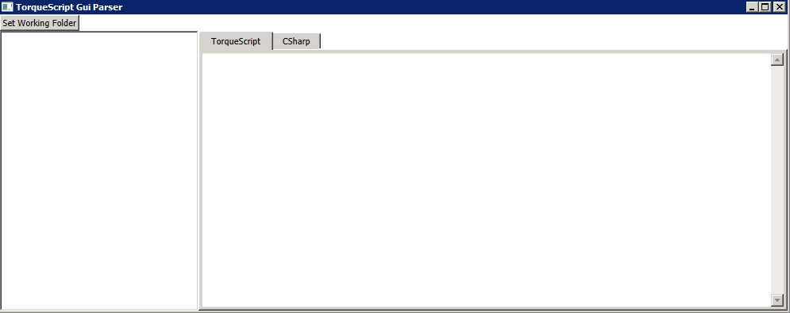

First set your working folder by clicking “Set Working Folder.”

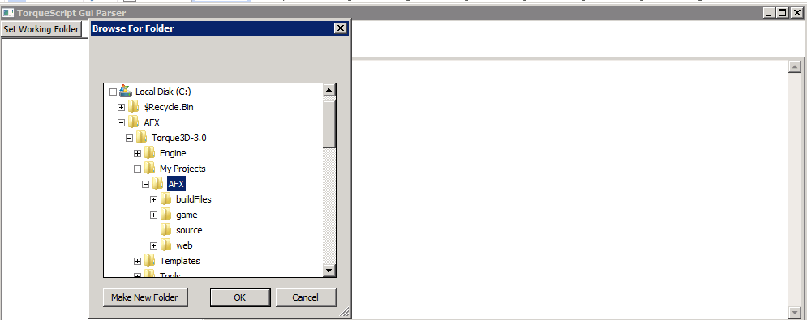

Once you set the working folder you will see a file tree on the left window.

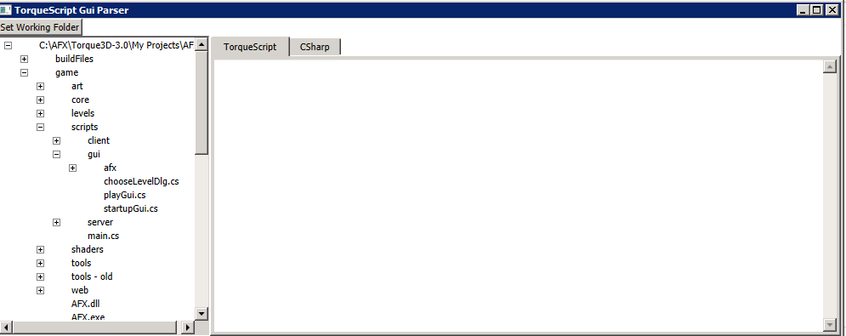

After navigating to where the Gui is saved in the game folder, click the file you wish to convert.

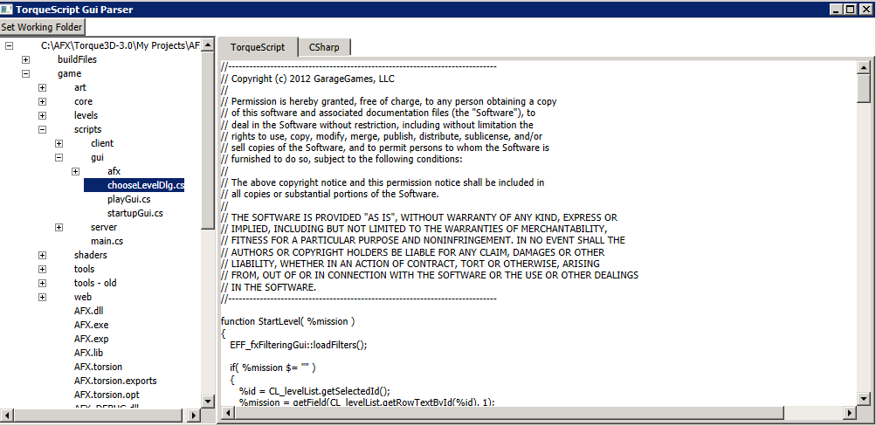

It will show you the TorqueScript source to the file on the “TorqueScript” tab and the C# code on the “CSharp” tab.

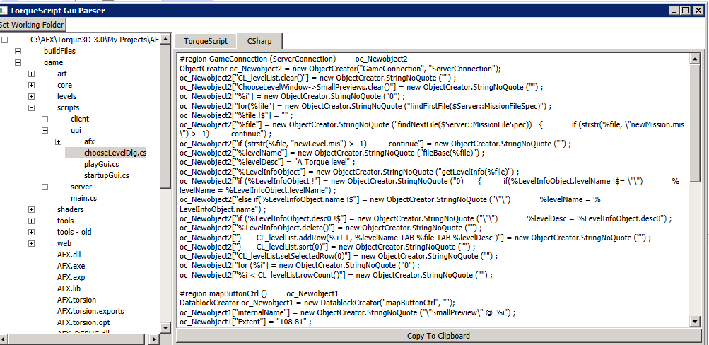

Just copy the generated code into a C# class as a static function and add a call to it to load the screen.

If you need to change your Gui, you can either edit the C# directly or edit the screen using the T3D built in screen editor, save the TorqueScript, open it in the parser and reconvert it putting the generated C# code back into your function.

## Advanced Gui Creation

The GuiParser takes ninety percent of the work out of converting TorqueScript Gui files to C#. But once the Gui is converted you still need to wire up the events.

The Omni Framework provides two methods to wire up events inside of Gui’s. You can either use the old style of putting the command to fire inside the click event, or wire the event up using the C# Model framework.

### Old Style

An example of putting the command to fire inside a click event would be:

**TorqueScript syntax:**



**C# Syntax**



Where oc_Newobject11 is some object creator and the CloseCommand is a member property on the T3D View object.

### New Style

First we would modify our code and add the C# Model name we wish to attach to the gui component.

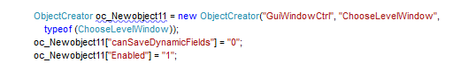

The above code sample is creating a new “GuiWindowCtrl” which is named “ChooseLevelWindow” and it is assigning the C# Model “ChooseLevelWindow” to it.

After assigning the C# Model to our T3D View, we then can create the view like such.

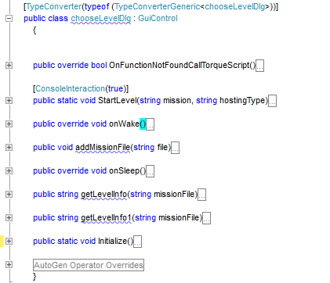

As you can see we are then able to override the events needed to handle things like mouse clicks, etc. This provides a clear and readable binding between the Gui objects and the code behind them.

Below is an example of a C# button Model.

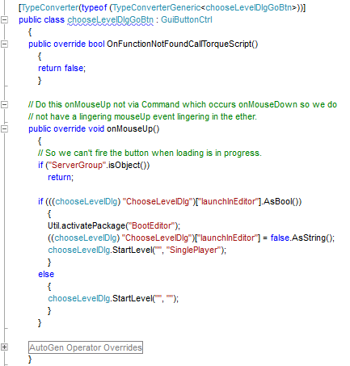

Ultimately the decision of which design paradigm to follow is up to the programmer, but it is highly recommended to use the Windows Form paradigm.

# Chapter 10 Global Functions

Due to the difference between TorqueScript and C#, it is not possible to define Global functions in some C# file outside of a class file. Because of this, the decision was made that all global functions would be declared inside a class file and the defining attribute that made them global was flagging the function as “static” in C#.

We moved all global functions that dangled all over the FPS Demo game into the class files they mostly applied to in an effort to organize them in a manageable way. So instead of having one static class with a long list of static functions, we moved the static functions into their respective classes.

There were cases when for C# naming convention purposes we ended up with same name used twice in two classes. Because of this we added the ability to take a static function and alias its name to something different.

This is done in the ConsoleInteraction decoration.



The above code would rename the static function “ToggleConsole” to “SomeAlias” when exposing it to the Omni T3D console. In the event we had more than one “ToggleConsole” function, we could alias them as “SomeAlias1”, “SomeAlias2”, “SomeAlias3”, etc.

This way if we had used the same static function name in more than one class, we could have it exposed to the console as something different for each class but structurally in C# the functions would be called the same.

For more information on Global Function implementation please see Chapter 6.

# Chapter 11 Run-Time C# Programming (LiveScripts!)

LiveScripts provides a mechanism to load C# Models and functions into the game without compiling them into the source code. This feature allows you to modify the running C# game scripts without restarting the game. Especially useful when debugging code during development or allowing end-users of your game to modify game play.

All LiveScripts must be in the Game/csScripts folder. When the game starts, it will read this folder and compile all of the C# code into an in-memory DLL. If the DLL compiles without errors, it is then loaded into the Omni Framework and it can be used just like any other class. Any time you change the C# or XML configuration files, all objects that are defined in the modified C# files or XML Files is automatically deleted from memory and passed for garbage collection.

NOTE:

If compilation errors occur when you save the C# script, you will need to re-save the XML file to have the C# script recompile.

File namespace should start with WinterLeaf.Demo.Full.Models.User (‘L’ in WinterLeaf is capital)

There are two types of LiveScripts:

1. **Classes** – Used when you wish to add new C# Model classes to your game.
2. **MemberConsoleFunctionOverride** – Used when you wish to replace or add a Console Function to a C# Model Class.

All LiveScripts require an XML file for configuration. An Example XML file is:

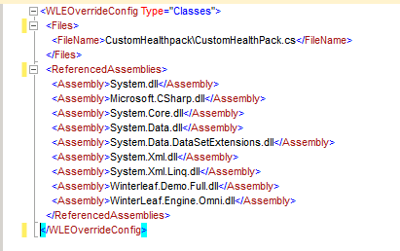

LiveScript will compile all of the <Files> into a DLL and register them inside the Omni Framework. Remember to add the referenced assemblies under <ReferencedAssemblies> tag, as shown in the picture above.

1. **Classes**:

**XML Configuration** -

* Define the <WLEOverrideConfig/OverrideConfig> Type to **Classes.**



* Add the new files under the <Files> tag.



* Add the referenced libraries/dlls inside the <ReferencedAssemblies> tag.

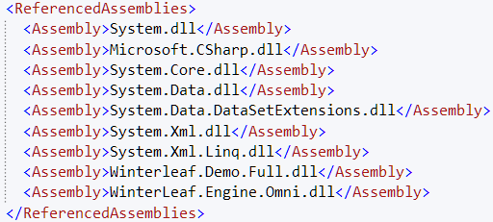

**C# file –**

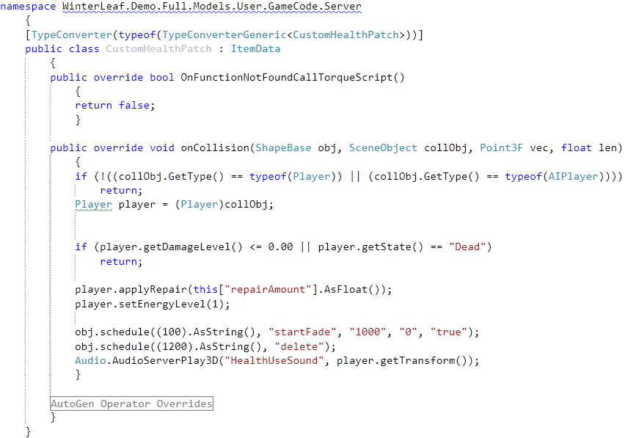

Above is the sample file for the **Classes**. It, basically, includes

* + **Namespace** – The Namespace under which the file should lie.
  + **TypeConverter attribute**– The Typeconverter attribute for the Class so that the type would be added to the system. [If, is a SimObject]
  + **Operator Overrides** – The operator overrides for the new generated class type so that the system knows the conversion mechanism for the new class object to OMNI types. [If, is a SimObject]
  + **ConsoleInteraction attribute** – If the member methods are allowed to be called from the OMNI console, they have to be decorated with this attribute.

1. **MemberConsoleFunctionOverride**:

**XML Configuration** -

* Define the <WLEOverrideConfig/OverrideConfig> Type to **MemberConsoleFunctionOverride**



* Define the <NameSpace> to the class you wish to add/override methods to.



In this case, **WinterLeaf.Demo.Full.Models.User.Extendable.Player** class is being overriden.

* The referenced libraries and the files to be included are referenced as in the case of **Classes**. 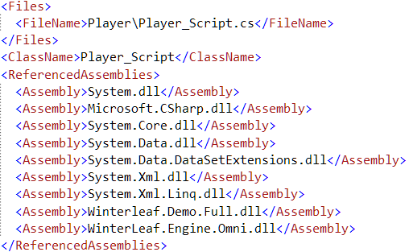
* Add the functions to be overriden/added under <FunctionOverrides>.

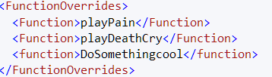

**C# file –**

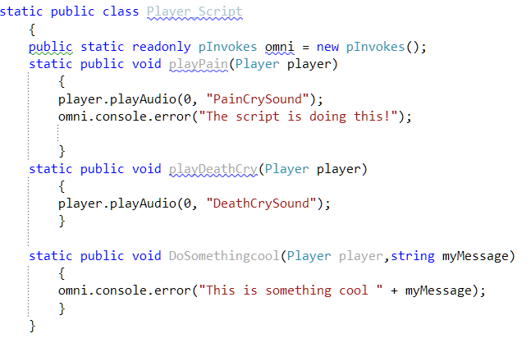

The MemberOverride file is a touch different. Requirements:

* + **Namespace –** Not required.
  + **TypeConverter attribute** – Not required.
  + **AutoGen Operator overrides** – Not required.
  + **Public Static class** – The class name should be public static.
  + **Public static methods** – The member or overridable methods should be static too, WITH first parameter as the class type to be overriden.
  + **ConsoleInteraction attribute** – Required if, the methods are to be exposed to the console.

TADA! With these simple steps, you’ll able to create a **livescript**, which can be edited without exiting your game/compiling into the game.

# Chapter 12 File Dialogs

OMNI uses a new way of using the file dialogs, as opposed to T3D. The file dialog in OMNI is used in combination with C# form file dialogs, so you can define a ton of different properties as per your need. The file dialogs support callbacks with the use of delegates. The callback function accepts the DialogResult as the parameter, and will be called after the dialog execution is complete. By default, it doesn’t include a callback.

This is a simple example of a **file dialog**.

Figure : File Dialog with delegate

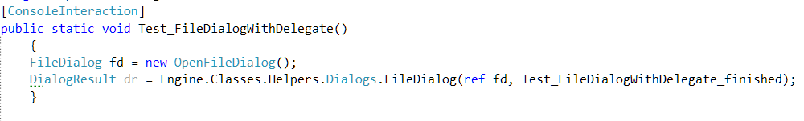

Figure : File Dialog without delegate

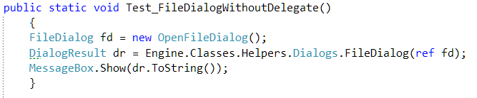

NOTE: Make sure you call Dialogs.GetForwardSlashFile to get the filename on request complete. This ensures you get the correct filename for use.

There are two type of file dialogs in OMNI.

1. **OpenFileDialog**:

For OpenFileDialog, you need to create an object of **System.Windows.Forms.OpenFileDialog** class and pass its reference to the static OpenFileDialog constructor.

If you need to use a callback for the dialog, you can pass the delegate as shown in Figure 1 above. Below is an example of OpenFileDialog:

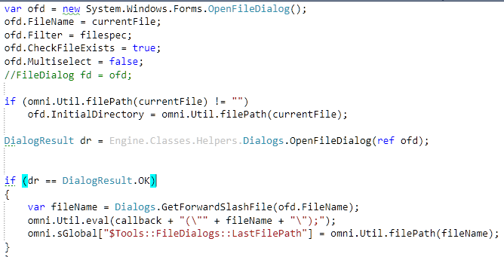

1. **SaveFileDialog:**

For SaveFileDialog, you have to create an object of **System.Windows.Forms.SaveFileDialog** and pass its reference to the static SaveFileDialog constructor. For the callback, you can use it the same way as OpenFileDialog.

This is a simple example of SaveFileDialog.

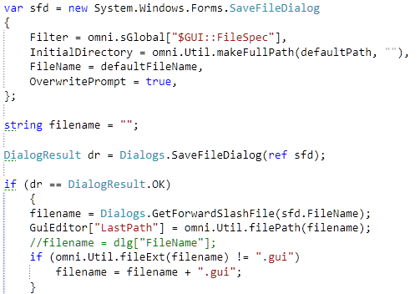

# Chapter 13 Threading with the Omni Framework

Interacting with T3D from an asynchronous thread can be tricky. Thankfully we have added a mechanism to the OMNI Framework to assist you.

First, let the reader be warned, Threading is an advanced topic and should be avoided unless absolutely necessary.

An example of threading is in the Model.User/GameCode/AI/AI.cs file. This class demonstrates how to do the threading properly.

This example’s purpose is to rid the logic from using the “Schedule” function inside of T3D. Instead we are keeping track of all AI’s in a collection and tracking there time when to activate outside of T3D.

The whole logic starts in the function “CreateAI”, this console function will create and spawn the AI monsters.

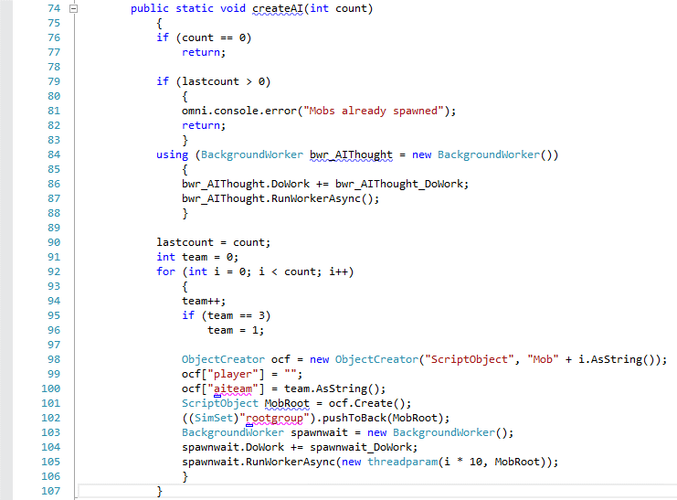

So, when you type into the console “CreateAI(10);” the function does some basic checks to make sure you haven’t spawned monsters already. This is done in lines 76 to 83. If you have spawned monsters already, the function quietly exits out.

Otherwise, the code will create a new BackgroundWorker (C# threading object) which will monitor a Queue of intervals that tell the C# when to process the thinking process for each AI.

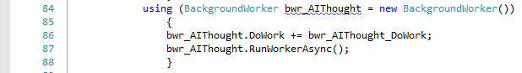

The syntax is pretty simple, line 84 we create the new BackgroundWorker object “bwr_AIThought”. We assign the name of the function to call when the thread is started on line 86.



Then we kick the thread of asynchronously on line 87.



We will get into what the “bwr_AIThought_Dowork” function does farther down, but lets look at the remaining code.

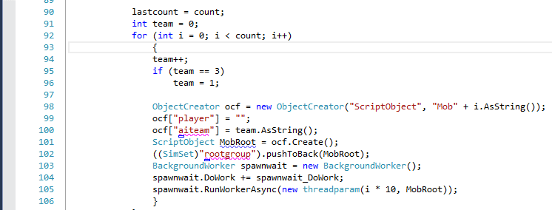

We are looping from 0 to “count” times, where count is the number of AI’s you wish to spawn. We create a new ScriptObject to manage our AI instance and assign the team number to it. After creating the ScriptObject on line 101, we then push it into the “rootgroup”.

This doesn’t create the AI, it creates an AI Manager, so now we need to kick off creating the AI. We could have used a “Schedule” call here.

On line 103, we create a new BackgroundWork object this time telling it to call the function “spawnwait_DoWork”, and we are passing a parameter to the function when we invoke the thread on line 105.

Looking at the code in “spawnwait_DoWork” we see:

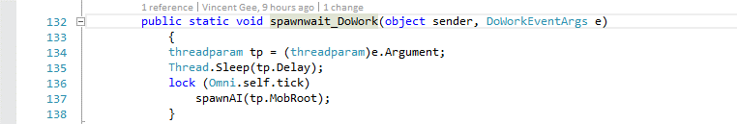

The background worker only allows us to pass one parameter to a thread, so if you need to send multiple parameters to a thread function, it must be inside a class. In this case we created a “threadparam” class to hold our values to be passed to this function.

The passed parameter object will always be in EventArgs.Argument object. To use it, we need to cast it back to our class type as seen on line 134.

So, in this code example this thread will read the arguments and sleep the thread for the delay specified, after the duration is over, the thread will lock the T3D process and inject a call to the function “spawnAI”. The syntax for locking the T3D process is



After locking the thread, we can then call the function “spawnAI” safely without worrying about corrupting the T3D memory stacks.

Now, going back to the function “bwr_AIThough_DoWork”.

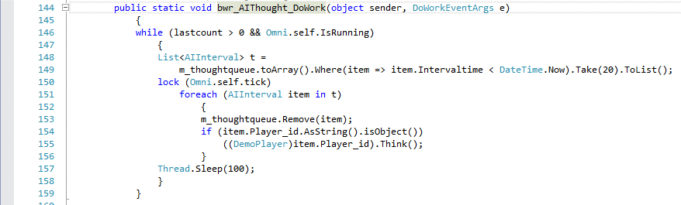

This function is in a continuous loop until the lastcount equal zero or the game is shut down. Using lambda we query our queue of AI’s that need to think where their interval time is less than the current system time and we only take the top 20 objects from the queue. This is to protect against say having 100 AI’s that need to think and processing them all at once which would cause a hitch in the game because it would pause the engine while it is processing there “Think” function.

So on line 150, we lock the “Tick” and start a loop through each of our fetched AIIntervals. The program removes the interval from the main queue and then checks to make sure that the player_ID is an object. This is the actual ID for the bot. If the bot exists, i.e. hasn’t been killed, we then call the “Think” function on that bot. Once all 20 bots have been processed the whole thread pauses 100 ms to give the simulation time to catch up before it repeats the process.

In a situation where you create 500 AI’s, the AI’s will begin to act very strange because even though you told the AI to think every 500 ms, it might not actually think for 600, 700 or 1000 ms due to load. Why would you do this?

Well if you were running 400 AI and using the T3D schedule routine to process there thought, there is a possibility that all 400 AI would process there thinking in order, thus stopping the game while it processed all 400. In this threading example we are limiting the engine to only processing 20 AI moves every 100 ms. So yes the AI can get backlogged, but the will never cause your game to crash or slow to a standstill.

The only hard rule in threading is that you must call “Lock(Omni.self.tick)” before interacting with the T3D dll from outside a callback from the engine.

# Chapter 14 Debugging C# and C++

Debugging is always a challenge, how can you debug the C++ and the C# at the same time. In this example I created a new project using the “C#-Full” template.

**NOTE: This only works with Visual Studio 2010/2013 Professional and higher. The express versions of Visual Studio do not allow mixed solutions.**

First thing to do is open up the “New Project.sln” inside of Visual Studio.

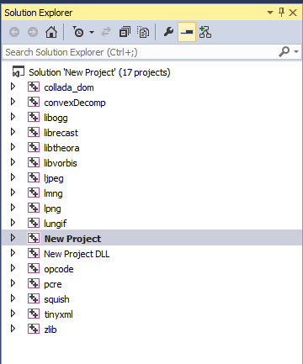

This looks like a normal T3D solution with all the C++ projects in it. Where are the C# projects?

Well since I had to set OMNI up for people who use the Express versions of Visual Studio I split the solutions into two separate solutions. All the C++ is in the <Project Name>.sln and all of the C# is in a solution called Omni Framework (<Project Name>).

The key to debugging is getting all the projects into one solution, so the first step is to add the C# projects to the C++ solution.

So click on the solution, right click -> add->Existing Project.

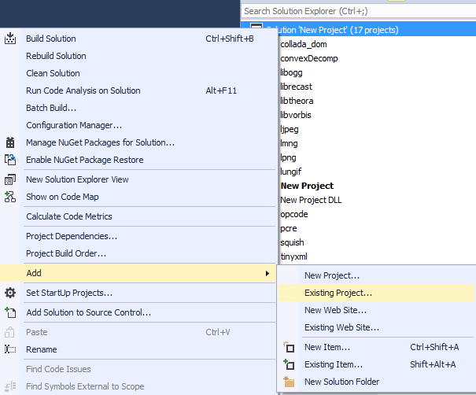

Navigate to your Project folder and into the “Winterleaf.Demo.Full” project folder.

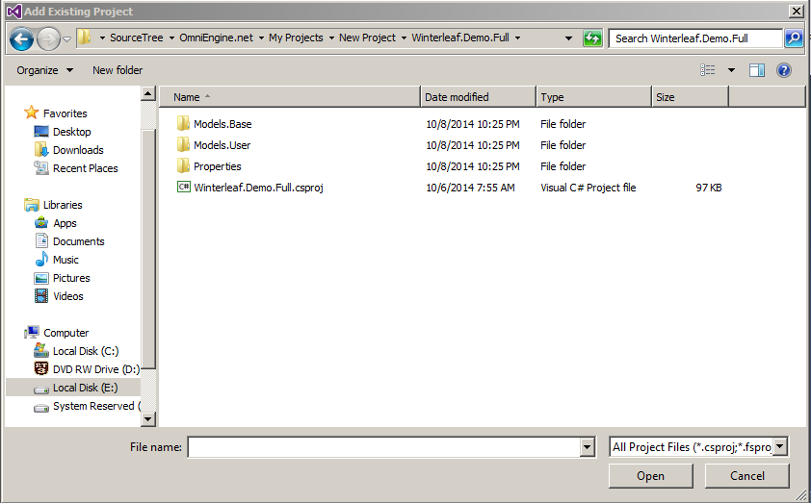

The solution should now look like the picture below.

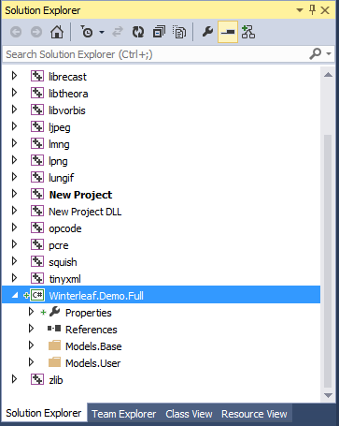

We repeat the process for the “Winterleaf.Engine.Omni” and “Winterleaf.Game” projects. After adding those two remaining projects to our C++ solution our solution should look like the picture below.

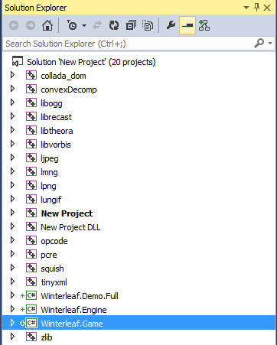

Now the next step is to configure the Build. So go to Build->Configuration Manager

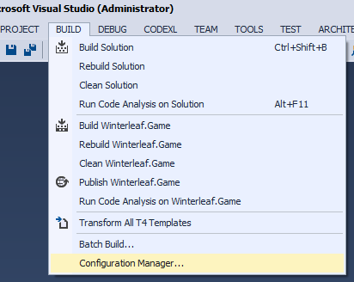

It should look something like this.

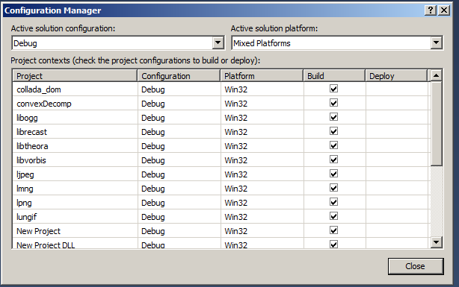

We need to change the “Active Solution Platform” to either “Win32” or “X64”, really your choice on whether to build the 32 or 64 bit executable. In my example I will choose the “X64” configuration.

Make sure that the C# projects are set to the same Build configuration as the C++ projects. If building a 64 bit configuration it should look like the following.



A 32 bit configuration would look like:

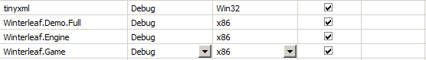

Since we are using OMNI we do not need to build the stock C++ executable anymore so we can uncheck that from the build.

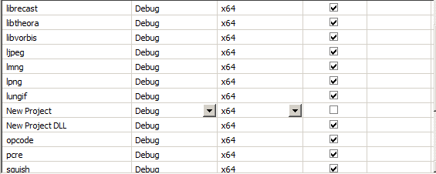

Now that we have the projects configured, we need to switch the startup application to our C# project. This is done by right clicking on “Winterleaf.Game”->Set as Startup Project.

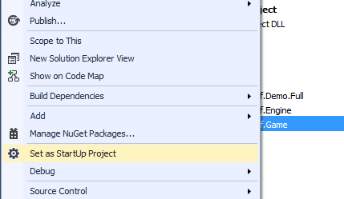

This tells Visual Studio that the project “Winterleaf.Game” is the project it should start when you fire up the debugger.

Next, we need to allow the debugger to be able to debug both the C++ and C# projects in the same session. To do this, right click on the “Winterleaf.Demo.Full” project and click properties.

Go to the “Debug” tab, and click the “Enable native code debugging” check box.

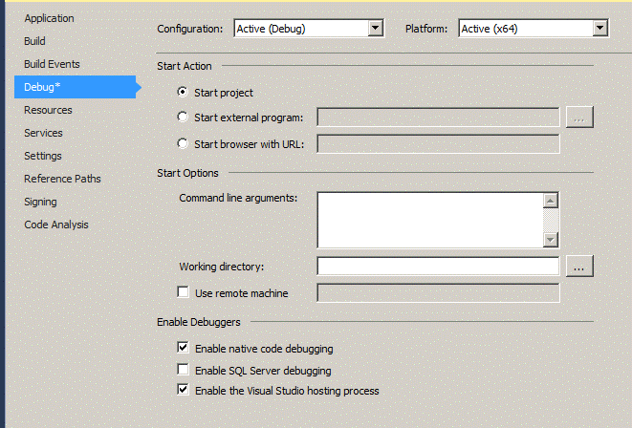

You will need to do this on each of the C# projects. This will allow you to set break points in both the C++ and the C# as well as step debug from the C# into the C++ and back out again while debugging.

Before building our new solution, make sure you run the Static Code Analyzer (Chapter 3).

After running the Static Code Analyzer you are then able to build the Solution.

After it is built, open the Winterleaf.Demo.Full project and navigate down to Model.User/GameCode/Main.cs. Place a breakpoint on line 46.

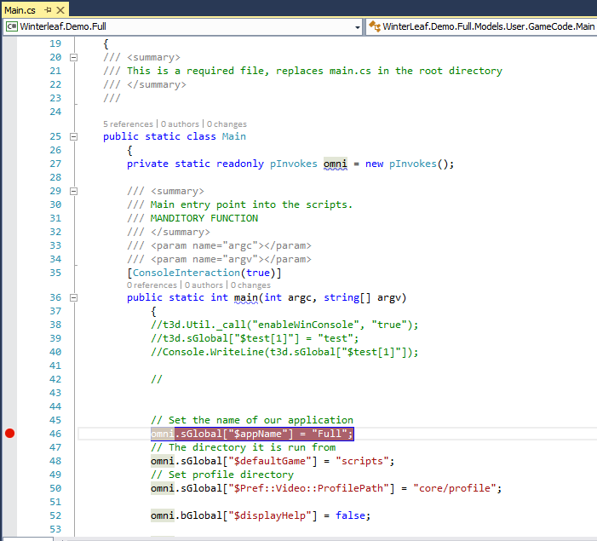

After placing the Break Point, start the game up in debug mode.

After starting the game, you should see a yellow highlight where your break point is

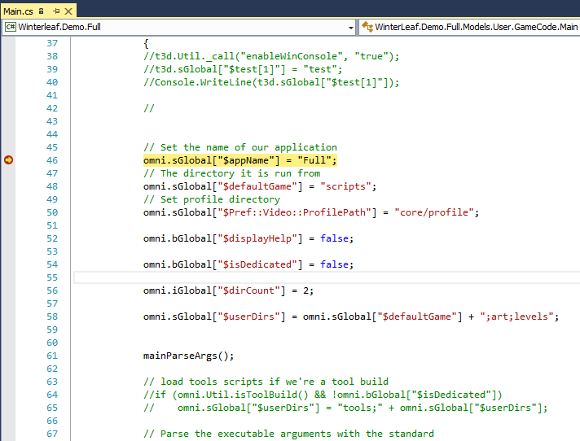

Enjoy Debugging!

# Appendix

## Appendix 1 - Static Code Generator Configuration Options

The Static Code Generator is an application which takes care of setting up the linkage between C# and C++. It achieves this by reading all of the C++ source code and generating Extern’s in the C++ and delegates in the C#. Without this application, the Omni Framework would not be possible due to how the C++ code can change over time.

Let us talk about configuring this monster!

### Configuring C++ Class pInvoke Serializations

This configuration file is responsible for parsing the different types of C++ structures between C++ and C#.

So for example,

In the C++ source code we have a parameter type of “VectorF”. To be able to pass a VectorF as a parameter or accept it as a return type from a C++ console function we need to provide how to translate it. So let’s look at the configuration for VectorF.

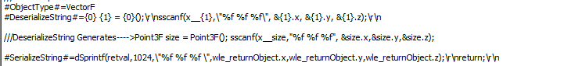

The DeserializeString tells the Static Code generator how to convert a string to the C++ object.

So in when the extern is generated in the C++, it changes the parameter type to a const char *, and inside the function it injects the deserializeString into it replacing the parameters with the variable name.

When a console method returns a VectorF, it replaces the return text with the serializeString to build the return value. So once again it replaces the placeholders with the variable name in the C++ code.

So, if you add a new object type to the engine which isn’t SimObject based and you have a need to pass it as a parameter or return type in a console function you will need to define the object here.

## Configuring C++ Class/Enum Map to C# Class/Enum

This configuration file is the second part to configuring C++ Class pInvoke Serializations. Once you have defined the serialization you need to tell the Static Code Analyzer what C# object maps to the C++ object.

So continuing our example of VectorF…



Here you can see we are mapping the Point3F C# class to the C++ VectorF class inside the Static Code Generator.

### Configuring C++ Class/Function Ignores

There are times when you want the Static Code Analyzer to ignore certain functions and or whole classes. They might be Console functions that you just don’t need or you can’t get to work correctly inside of the Static Code Generator.

### Configuring C++ Constants

This configuration file is used to define the C# equivalent to the C++ constant.

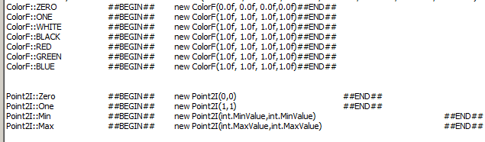

In the C++ code, you might have default parameters set up for the Console Function. The Static Code Generator will attempt to convert them to C#. Usually, if the constant is not defined in this file, the result will be code generated in error.

### Configuring C++ Return Type Casting Overrides

We need to provide a mapping between C++ and C# base object types. This is because the type conversion between C++ and C# are not always clear, and also since you might use a #Define in the C++ to redefine a base type. Usually this file is reserved for defining enumerations and types that are redefined with #Defines.

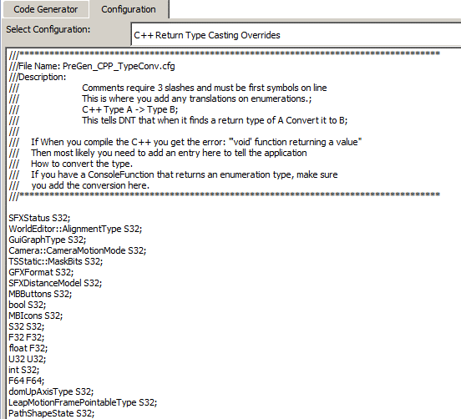

### Configuring C++ SimObject Based Classes

Whenever you add a new object type which is derived from the SimObject base class you need to add it to this file. Usually, the Static Code Generator will spew out an error stating that “The Class XXXX is not defined, if it is a SimObject based class please add it to the C++ Simobject Based Classes.”

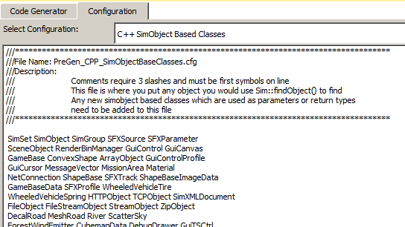

This configuration file is nothing more than a catch all, so you don’t have to define a serialize/de-serialize for every SimObject based type.

### Configuring C++ Source Files To Ignore For Enumeration Parsing

There are just some C++ classes where the enumerations contained in the C++ code serve no purpose to the interopt between C++ and C#. By putting the name of the file in this configuration file, the Static Code Analyzer will not parse those files for enumerations.

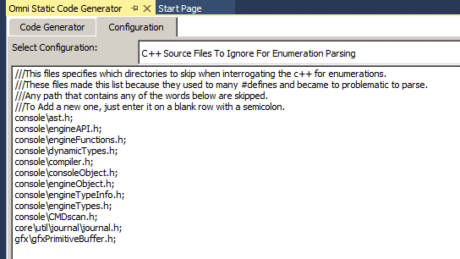

### Configuring C++ Source Files To Ignore On Interrogation

This configuration file specifies the files to completely ignore when parsing the source code. Any file listed in this configuration will not be processed. It is basically an exclusion list for the Static Code Generator.

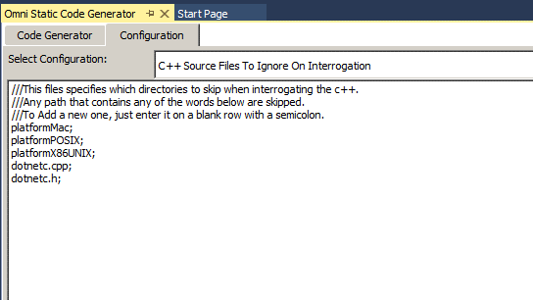

## Appendix 2 - Special Omni C# Syntax

All the decorations used in DNT have been replaced with a single C# Decoration. The new decoration is “ConsoleInteraction”. The “ConsoleInteraction” decoration tells the Omni Framework to expose the function as a callable function from the C++ console. The decoration is not necessary for functions which are overridden base functions, in those cases it is implied.

There are two usages available for this decoration. Under normal circumstance the default decoration, “[ConsoleInteraction()]” will suffice. This flags the member function for use in the console.

If this decoration is used on a static function then that function is exposed to the console as a global function versus a member function.

An example of the difference is:



Exposes the function OnServerMessage as a global function in the console. From the game console you could type “onServerMessage(“blah”);” and the engine would call the function. This if different than member functions which would have a signature like:



This function would only be exposed as a member function to an object. To invoke this object you would need to know the name or id of the object followed by a period and the function. To call this function you would have to type something like “MyObject.Respawn();”.

In regards to Global functions exposed to the console. There are times when in C# you are following a naming convention and you will end up with two static functions called the same thing. For example you have an “Initialize()” function that you want to expose to the console. Unfortunately, “Initialize” could be used as a name for a static function in more than one class. Thus causing a problem since Global functions must be unique.

In this case you would have to pass an alias to the ConsoleInteraction decoration like such:



This tells the Omni Framework to Alias the global static function “Initialize” as “ConvexEditor_Initialize”.

NOTES:

Exposed Static Functions must be unique across all classes.

Functions are not case sensitive, so for the framework “OnNewItem” is the same as “onnewitem”. So even though C# function naming is type sensitive, having two functions with the same spelling will throw an exception that the function is already defined.

Namespaces are also very important inside the Omni Framework. You can use any namespace for you custom code. But you cannot mix namespace base names in your code. In the example provided in the FPS demo, you will see that the base namespace is “WinterLeaf.Demo.Full”. So pick a namespace and stay with it.

Also, once you have a namespace set it in the project properties for the C# library.

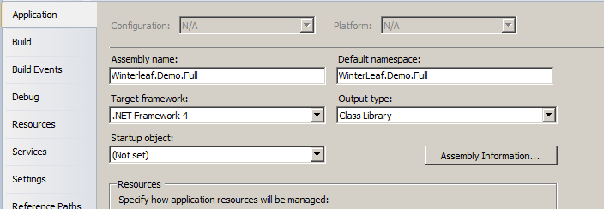

## Appendix 3 - Built in conversion functions for Casting.

Omni has built in conversion functions for converting strings into various other types. These conversion functions are written as C# Extensions and are defined in the Engine project.

When casting from a number to a string type use the “AsString()” function versus the C# stock function “ToString()”. “AsString()” handles precision and conversions for Booleans properly. Also when casting from strings to number types use the appropriate “As<Type>()” function. These functions were written to limit the expose to TryParse and Try/Catch blocks for performance reasons.

## Appendix 4 - Casting Game Objects

Time to time you will need to cast complex objects. C# allows you to cast a derived object to a base object with no problem. This is the base functionality of C#, for example:

namespace TestApp

{

public class ClassA

{

public int a;

}

public class ClassB : ClassA

{

public int b;

}

public class ClassC : ClassB

{

public int c;

}

public class test

{

public void CastMeOk()

{

ClassC c = new ClassC();

ClassA a = c; //Implicit cast, this is allowed

}

public void CastMeBad()

{

ClassA a = new ClassA();

ClassC c = a; //Invalid cast, cannot upward cast an object.

}

}

}

This is a base foundation of C#. You cannot cast a base class to a derived class without writing something that does the dirty work for you.

This leaves a problem with programming with events like collisions. Think of the situation when we have a “HealthPatch”, a “Player” and a “AIPlayer”. Now, many objects will collide with the “HealthPatch”, but we only want to do something if it is of a type of “Player” or “AIPlayer”. How do we handle it because the signature for the inherited collision function is:

public override void onCollision(ShapeBase obj, SceneObject collObj, Point3F vec, float len)

This means that the function is passing a “ShapeBase” object and we can’t cast it up in C# to a player or AI.

This is overcome by the Proxy Object Cache. When a simulation object is created in the C++, a proxy object of the same type is also created for it in the C#. BUT, Omni saves the proxy C# class instance in a collection of “ModelBase” which is our base proxy object class definition type.

So this means that all proxy objects are actually of our base class type and of our derived type at the same time. Because of this we are always casting objects down (Which is allowed) even though it may seem we are casting objects up.

This example of code is from the HealthPatch proxy object.

public override void onCollision(ShapeBase obj, SceneObject collObj, Point3F vec, float len)

{

if (!((collObj.GetType() == typeof (Player)) || (collObj.GetType() == typeof (AIPlayer))))

return;

Player player = (Player) collObj;

if (player.getDamageLevel() <= 0.00 || player.getState() == "Dead")

return;

.

.

.

}

So even though the parameter coming in is of a lower defined class type, we can cast it up to a Player object, since in reality it could be a Player, AIPlayer, or any other scene object type instance of an object.

The concept works like below.

public void CastMeOk()

{

ClassA a = new ClassC();

ClassC c = (ClassC)a; //Implicit cast, this is allowed

}

So with basic type checking, we can use objects that are defined farther down in the inheritance model at any point from there instance to the base object type of “ModelBase”.

## Appendix 5 - Overriding functions and such

The Omni Framework uses function overriding quite heavily. This is the process of deriving a base object and inheriting it and potentially replacing functionality of an inherited function.

More info is available at <http://msdn.microsoft.com/en-us/library/ms173149.aspx>.

## Appendix 6 - Creating Objects (ObjectCreator/SingletonCreator/DatablockCreator)

At some point you will need to create in game objects. This is done using the “ObjectCreator” helper class in the Omni Framework. The ObjectCreator class simplifies object creation.

An example used in the Winterleaf.Demo.Full project:

public static UInt32 Spawn(string name, TransformF spawnpoint)

{

ObjectCreator npcScriptObject = new ObjectCreator("AIPlayer", "", typeof (DemoPlayer));

npcScriptObject["dataBlock"] = "DemoPlayer";

npcScriptObject["path"] = "";

coAIPlayer npc = npcScriptObject.Create();

.

.

.

return npc;

}

The ObjectCreator uses a constructor that expects three parameters. They are:

1. Name of the C++ Simulation Object Class
2. Name Alias for the new instance
3. Optional, the Proxy Class to bind the C++ object to.

In this case we are creating an “AIPlayer” C++ object, we are not assigning a name to it, so it will be only available by SimObjectID and we are telling it to bind the C++ object instance to an instance of our “DemoPlayer” class. Had we omitted the last parameter it would have used the stock proxy class of “AIPlayer”.

The ObjectCreator exposes a Dictionary key/value pair that lets you send in initializing parameters. These parameters will be set when the C++ engine creates the instance of the object you requested.

In the above code we are setting a property “dataBlock” equal to “DemoPlayer”. This datablock is defined in the folder “Game/Art/Datablocks/AIPlayer.cs”.

The second parameter we are setting is the “Path” parameter. This is just a path defined in the mission that this AI will follow.

To create the object we just call the member function “Create” which will pass your creation request to the C++ and return the ID of the object back if it was successful or zero if it failed.

The ObjectCreator collection value type is variant. This means, any C# class type which provides a “toString()” function can be assigned as a property of the initialization of the object.

This bit of code demonstrates that the value fields truly can be anything serializable to a string.

ObjectCreator tch = new ObjectCreator(this["projectileType"]);

tch["dataBlock"] = this["projectile"];

tch["initialVelocity"] = muzzleVelocity;

tch["initialPosition"] = obj.getMuzzlePoint(slot);

tch["sourceObject"] = obj;

tch["sourceSlot"] = slot;

tch["client"] = obj["client"];

tch["sourceClass"] = obj.getClassName();

Projectile projectile = tch.Create();

So in general, when creating objects you can assign Point3F’s, integers, floats, or even your own class’s as values as long as they implement and override the “ToString()” function.

### Gui’s and nested Objects

There are times when you will need to nest object creations. This usually occurs usually in the creation of Gui’s. To accommodate this you can assign ObjectCreator instances as values to another ObjectCreator. Since the ObjectCreator, SingletonCreator, and Datablock creator all provide a “ToString()” function they can be used as parameters to themselves. When assigning an ObjectCreator as a property to another ObjectCreator, the property must be marked with a ‘#’ sign. This tells the creator that it is a child creator property.

ObjectCreator oc_Newobject2 = new ObjectCreator("GuiBitmapBorderCtrl", "");

oc_Newobject2["canSave"] = "1";

oc_Newobject2["canSaveDynamicFields"] = "0";

oc_Newobject109["#Newobject2"] = oc_Newobject2;

## Appendix 7 - uGlobal, sGlobal, iGlobal, bGlobal, fGlobal, dGlobal, fGlobal

These properties provide access to the global console variables defined inside of the C++ engine. Since all variables inside the C++ are of type string, these functions provide convenient casting to commonly used types in C#.

* uGlobal – Unsigned Integer
* sGlobal – String
* iGlobal – Integer
* bGlobal – Boolean
* fGlobal - Float
* dGlobal – Decimal
* fGlobal – Float

Global console global variables are denoted with a “$”.

## Appendix 8 – OMG I have a ton of “WARNING:: COULD NOT RESOLVE… in my console”

A sample console would look like the image below.

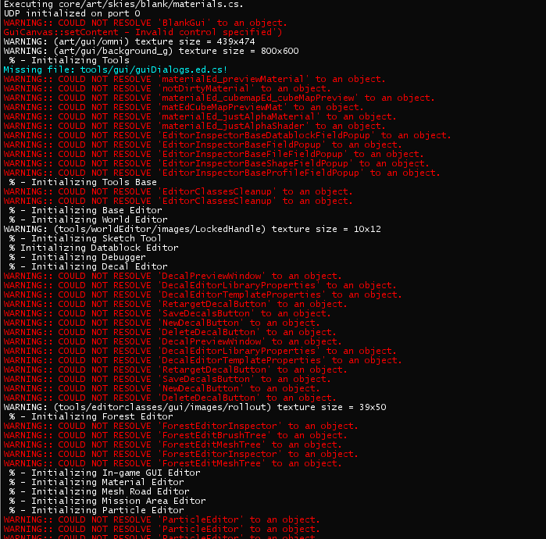

This is normal in debug mode and remember it’s just a warning. Basically there is a script trying to reference an object by name and that object doesn’t exist inside of T3D yet. If the messages continue after the initial startup of the game then you might want to research further to make sure you didn’t misspell the object.

## Appendix 9 - Where did “ClassNameSpace” and “superclass” go?

They still exist but they are no longer needed. In T3D inheritance was limited to 2 layers. Instead of using ClassNameSpace and SuperClass, one should derive the classes in the appropriate order. So the superclass would be the base, which the ClassNamespace would inherit from, which your class in turn then inherits from.

Unlike TorqueScript, you have unlimited inheritance in OMNI due to C#. There is nothing preventing you from taking a base object and inheriting it over and over again to define subtle changes in behavior.

A note of warning, do not mix TorqueScript syntax w/ C#. The console does not handling switching and gets confused when both are used. If you are using Omni, it is highly recommended that you dispose of all your “ClassNamepspace” and “Superclass” structures and convert them to inheritance.